SHARIAH SCREENING OF COMPANIES IN NIGERIA: LESSONS FROM OTHER JURISDICTIONS
Aishat Abdul-Qadir Zubair
(CSAA, LL. B, B.L, MCL, PCIBF, PCIED, Ph.D. <In View>)
Email: aisha.zubair@kwasu.edu.ng
ayyeesha@gmail.com
ABSTRACT
Background
The absence of Shari’ah screening methodology for companies in Nigeria has further engineered the uncertainty surrounding the acceptability of investing in certain companies by Islamic Ethical investors. This is due to the nature of the business activities carried out by these companies. Leveraging on the existing shariah screening indices in other jurisdictions, this paper recommends criteria that can be used to screen shariah compliant status of companies. These indices have tried to ensure that there are shariah benchmarks to be determined before investing in companies carrying out mixed business activities.
Purpose
There have been numerous studies on the need to adopt certain screening methodologies as well as call for new methods in screening companies for shariah compliance to suit the investment needs of Muslims in other jurisdictions. It is however unclear how suitable these methodologies will be to Nigeria. This paper, therefore, seeks to address this gap to consider an appropriate screening methodology to be employed in Nigeria drawing from the experience of other jurisdictions.
Methods
This study employs a triangulation of both quantitative and qualitative methods to analyse the need for Shari’ah screening of companies in Nigeria. The qualitative method is used by way of ijtihad through the application of principles of maqasid al-shari’ah and qawaid al-Fiqhiyyah to analyse the activities of companies to ensure that they are Shari’ah compliant. In addition, using the quantitative data gathered from the interview survey, the perspective of the investors about the need for Shari’ah screening of companies in Nigeria is further analysed.
Results
The result of the study shows that there is a lack of awareness from the Muslim population in Nigeria on the need for Shari’ah screening of companies in Nigeria. The result further shows that there is the need to take into cognizance the peculiar nature of business activities in Nigeria before any particular Shari’ah screening methodology and necessary benchmarks will be adopted.
Conclusion and Implications
The study concludes that there is a need to ensure that the Muslims in Nigeria screen companies for Shari’ah compliance so that they can easily identify shariah compliant companies for investment purposes. The paper, therefore, recommends that business regulators in Nigeria need to come up with a screening methodology that will suit the peculiar nature of companies in Nigeria. The study thus has direct implications on the investment regulatory bodies in Nigeria such as the Securities and Exchange Commission (SEC), Central Bank of Nigeria (CBN) as well as the investor Muslims.
Keywords: Shari’ah Screening; Muslims; Investors; Companies
- INTRODUCTION
Nigeria is arguably a secular state and so the laws and modus operandi of its major parastatals and organizations are secular in nature. So is the case with the Securities and Exchange Commission that regulates investment in equities of companies in Nigeria. It has therefore not been made their major concern to have a shari’ah screening for companies to ascertain their shari’ah compliant level or otherwise. Muslim Investors are therefore left to their fate in deciding which company to invest in. However, if we consider the fact that Nigeria has a huge market potential of Muslim Investors who are willing to invest only in shari’ah-compliant companies, the case of the Islamic financial products hugely oversubscribed to attesting to this, then the need for a shari’ah screening methodology for Nigeria becomes long over-due.
However, Islam being an all-encompassing religion explains every aspect of human life from his Ibadat to his Muamalat and in every other aspect of his existence in this world and the next. It is for this reason that a Muslim needs to ensure that in all his dealings, in this case, his investment in companies, he stays compliant with the shari’ah in all ramifications. All these efforts are geared towards bringing Muslims to obey the command of their creator Allah as is stated in many verses of the Glorious Qur’an one of which is
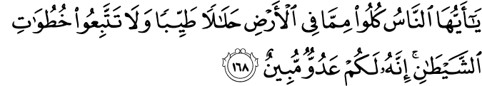
O mankind! Eat of that which is lawful and good on the earth, and follow not the footsteps of Shaitan. Verily, he is to you an open enemy.
Drawing from examples in other jurisdictions like Malaysia, there is the need to come up with criteria for distinguishing between companies whose activities are Shari’ah compliant and the ones that are not. A unique Shariah Screening index is proposed at the end of the paper based on FTSE, Standards, and Poor among other shariah screening methods. There is therefore the need to consider the core activity of such companies as well as the non-core activity of the companies using the Shariah screening assessment as a major parameter in doing the same. This paper aims at drawing evidence from the major sources of the shari’ah such as the Qur’an, Sunnah, and al-Qowaid al-Fiqhiyyah for shari’ah Screening methodology.
The paper begins with an introduction; a review of relevant literature; a detailed explanation of the research methodology used; discussions on results and findings which begins with the discussions on the principles of equity investment in Islam. A detailed analysis of some of the existing businesses and companies in Nigeria is then made to lay the foundation for the need for shariah screening. The next section after that then explores some of the existing shariah screening indices and the criteria being used by them. Evidence of this exercise is then drawn from the major sources of shari’ah on screening of businesses the Islamic way. The last section just before the conclusion then proposes a screening index used in determining the shari’ah nature of companies tested in by Muslims and illustrates the business screening process with a case study. The paper concludes with specific recommendations to relevant government authorities on the need to come up with a shari’ah screening methodology and index for the Nigerian Capital Market.

- LITERATURE REVIEW
Shari’ah screening of stocks has been ongoing for decades in jurisdictions such as Malaysia. Nigeria has however just recently (about a decade ago) entered the Islamic Finance market, hence the justification for its silent approach towards shari’ah screening. However, this justification may not hold water considering the teeming Muslim population among its citizenry and their activeness in the business sector of the economy and capital market.
To encourage and facilitate Muslims investing in only Shari’ah-compliant stocks, investment in joint stock businesses with fully compatible business practices is permitted by the International Islamic Fiqh Academy of the Organization of Islamic Cooperation (IIFA-OIC). As a result, it prohibited participation in businesses whose business operations are either illegal or comprise both legal and illegal parts (IIFA-OIC, 2000, Resolution # 63/1/7). In its resolution from 1995, the Islamic Fiqh Council (IFC) of the Muslim World League (MWL) likewise agreed with the IIFA-position OICs.
Some of the major indices involved in shari’ah screening of stocks and companies include Accounting and Auditing Organization for Islamic Financial Institutions (AAOIFI); Dow Jones Islamic Market Indexes (DJIMI); Kuala Lumpur Shariah Index (KLSI); Financial Times Stock Exchange Shariah Global Equity Index (FTSE); Standard & Poor’s Shariah Indices (S&P); Morgan Stanley Capital International World Islamic Indices (MSCI); Thompson Reuters Ideal Ratings Islamic Indices; STOXX Europe Islamic Index; and ISRA Bloomberg Shariah Stock Screening Indices.
An attempt has been made to explain the different screening methodologies being used in Malaysia to the extent that there are now ongoing discussions on the differences and similarities that are in the different indices as well as the methodologies being used. For example, while comparing the methodologies used by different indices in Malaysia, it was discovered that companies that are considered to be shari’ah compliant under Bursa Malaysia are not so considered under the other four indices.
Another study’s attempt at comparing the methodology used by the major shari’ah indices in the world finds that all the indices employed the use of the two-tier methodology i.e., both qualitative and quantitative, however, some indices are more lenient in their approach than others.
Therefore, because of the differences discovered in the methodologies used by the different indices, there has been a call for harmonization of shari’ah screening methodologies by various researchers. A study thus proposed harmonization and standardization of shari’ah screening methodologies with the use of a new shari’ah approach.
Furthermore, while exploring the practical application of the shari’ah screening process and how it could be enhanced by converging the same with the ethical screening of stocks, it was found that there is scope to converge ethical screening of stocks with shari’ah screening as the lex loci applicable to shari’ah screening is derived from shari’ah, which considers ethics as part of determining its rules.
Moreover, a study discusses the criteria, processes as well as tediousness involved in the screening for shari’ah compliant and proposes a feasible solution to be undertaken to assist in the shari’ah screening process by suggesting another approach to shari’ah screening. However, an interesting analysis of the impact of applying alternative shari’ah screening on the resulting universe of halal assets shows that shari’ah screening procedures currently used in practice are inconsistent between halal and haram.
This review of the literature shows the extent to which discussions on shari’ah screening have gone in Malaysia and the need to replicate such practice in the Nigerian financial market by first adopting an unfavourable screening methodology and establishing a standard shari’ah screening index.
- RESEARCH METHODOLOGY
The research aims to consider and recommend an appropriate screening methodology for shari’ah in the screening of companies in Nigeria. While the sources of shari’ah will be analysed using the qualitative methodology, the Interview methods are employed for use under the quantitative methodology.
Data were collected through a shorter case study interview approach. Interviews were conducted with 5 individuals who are believed to be major stakeholders in Islamic Finance in Nigeria such as the industrial players, regulators, and Muslim Investors. Due to the concept of anonymity and confidentiality the names of these individuals will not be disclosed. Information obtained was a primary source (from the interviews), it was, therefore, unethical to reveal the identity of the organizations. The profile of all interviewees is as follows:
Interviewee | Gender | Level of Education | Position
A | Male | Ph.D. | SEC staff
B | Female | MSc | Banker
C | Female | Ph.D. | Shari’ah committee member of IFI
D | Male | Ph.D. | Lecturer
E | Male | MSc | Banker

The interviews focused on the Shariah screening based on interview protocol and lasted around one hour for each session. The interview protocol or known as the interview guideline was developed to ensure that the data collected can achieve the objectives of the study. In addition, probing was also adopted to ensure collected data revealed ‘what we think they reveal’. Interview protocol questions were prepared by focusing on the three aspects. These two aspects are (i) justification behind shari’ah screening assessments; and (ii) shari’ah-compliant status. Subsequently, a phenomenological approach to analysing data was adopted, which involves interpreting and reflecting on the data transcription to achieve a holistic understanding of the meaning of the participants’ experiences. In this case, all the interviews were reviewed several times before being transcribed. Meanwhile, for reporting purposes, this study employed a single-case study approach. This approach was used by combining all selected individual information into single writing. The two aspects mentioned above were the main focus and were used as themes in analysing and reporting the findings. To ensure that every statement was documented, the interviews were recorded after seeking the permission of the interviewees. The interviews were conducted from the beginning of May 2020 until the Middle of July 2022 via face-to-face and video call (Zoom App) approach.
- FINDINGS AND DISCUSSIONS
4.1 Equity Investment in Islam
Islam encourages investment in equities as well as companies and businesses that carry on halal deals. Generally, investment in the equity market could either be through direct investment or indirect investment. Direct investment is the main form of participation in the equity market which could be through the primary level by having shares in companies and corporations while it could also be through the secondary market on the stock exchange or otherwise through the sale and transfer of shares and stocks. The indirect investment on the other hand involves investing in funds/unit trusts through funds/unit trust companies that manage the funds by purchasing shares, bonds, and other securities in companies.
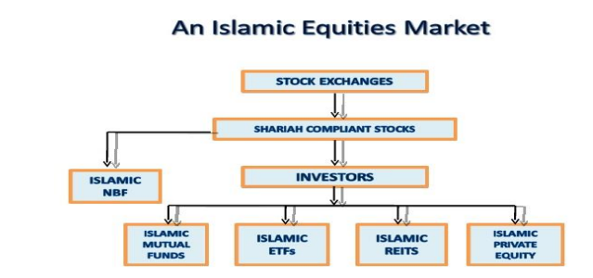
Source: Najib et. al, 2014
There are however rules to follow before investing in just any kind of business or buying equities of companies. These are in form of principles such as, first, shareholding is the main underlying investment activity. The certificate given to a shareholder usually signifies a form of capital contribution to a company. The shares can then be sold by the shareholder at any price (market value) as it represents the assets owned by the company. The investment in the shares can be in the form of Mudarabah or musharakah. Second, The Investments must be in businesses acceptable to shari’ah. Third, there should not be a guaranteed fixed return tied to the investments such that the principal and the profit would be guaranteed by a partner to the contract. One of the interviewees (Interviewee A) stated that what usually attracts him to invest in businesses is when the principal and the profit are guaranteed. This assertion was corroborated by another interviewee (Interviewee B).
4.2 Businesses and Companies in Nigeria
There are numerous businesses and companies for investment purposes in Nigeria despite the economic realities in the country. However, while there exist businesses and companies that engage in purely Islamic activities which makes them halal for Muslims to invest in (Islamic banks, takaful companies, etc), some are purely haram and therefore forbidden for Muslims to buy their shares (Nigerian brewery, lottery companies, etc). On the other hand, some companies engage in mixed activities where some will be halal and others will be haram. Some businesses combine the Multi-Level Medium Pyramid feature and genuine product sales like their business engagements such as Oriflame, Kedi, Pure, Trevor, etc (Most of these companies have been striving in Nigeria even better than they did in other countries). This Multi-Level Medium form of business has become so rampant in the country that almost all form of business tries to incorporate it into their operations to attract investors who are interested in such a scheme. In some businesses, it becomes apparent that the main target of the promoters of such companies is more of the MLM scheme than it is to get their product sold while in some businesses it is not so obvious. One of the Interviewees (Interviewee D) claimed not to be aware of any shari’ah issue with the such scheme.
4.3 The Practice of Shari’ah Screening
Muhammad Taqi Usmani (Pakistan) formed a team with Professor Saleh Tug (Turkey) and Sheikh Mohammad Al-Tayyeb Al-Najar (Egypt) to frame the initial shari’ah screening criteria of Islamic stocks. Malaysia is known to be the first country that formulated a shari’ah screening methodology in the mid-1990s. In 1995, with quantitative and qualitative assessments, a comprehensive Shari’ah screening methodology for stocks was introduced by the Shari’ah Advisory Council (SAC) of the Securities Commission (SC) of Malaysia. In June 1997, the first list of screened Shari’ah-investable stocks was announced in the country.
Figure 1. Showing the Shari’ah Screening Methodologies
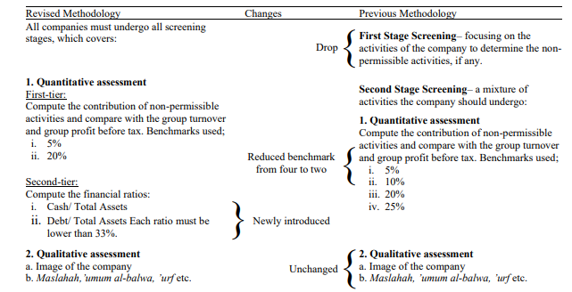
Source: Tanin et. al, 2021
There are some existing shari’ah screening indices whose criteria can be used to check if a company or business is shari’ah compliant or not. Examples are the FTSE Shari’ah Index, Dow-Jones Islamic Market (DJIM), and Standard and Poor Shari’ah Index (S&P) to mention but a few. What they have tried to do is to ensure that there are benchmarks to check with before investing in companies that have somewhat mixed activities going on in their business wherein some are halal and others are not.
It is important to note that there are the financial ratio benchmarks as well as the business activity benchmarks used to screen companies. What the financial ratio benchmark does is screen the financial strength of the halal income against the haram income and determine whether such a company can remain shariah compliant or not. On the other hand, the business activity screening benchmarks ensure that the halal activities of the company are more apparent and form the major source of income of the company than the haram activities do to ensure that it would be shariah compliant. However, in some indices, three stages of screening are considered paramount. These are industry screening; income statement; and balance sheet.
Figure 2. Showing the financial measure of some Indices.
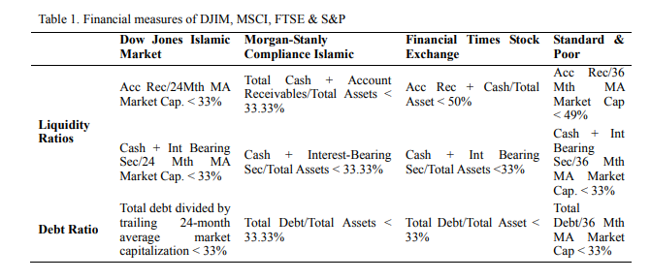
Source: (Gholamreza Zandi, Dzuljastri Abdul Razak & Nur Hidayah Hussin, 2014)
Similarly, the methodology employed by these indices ranges from both qualitative and quantitative. Business activities are considered qualitative in nature with both financial activities’ orientation as well as non-financial activities orientation; while the financial ratios are considered quantitative which can further be re-categorized by the adoption of the different numerators, denominators, and percentage of tolerance used. The different denominators used in calculating quantitative shariah screening rationalize the total assets and the market capitalization KLSI, MSCI, FTSE, and STOXX Europe Islamic index use the former while DJIMI, AAOIFI, S&P, Thompson Reuters Ideal Ratings Islamic Indices, and ISRA Bloomberg use the latter,
Figure 3: Showing the different Numerator and Denominator adopted by the Indices
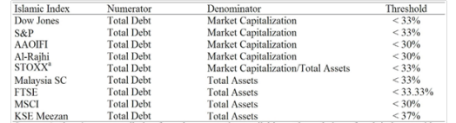
Source: (Gholamreza Zandi, Dzuljastri Abdul Razak & Nur Hidayah Hussin, 2014)
From the perspective of interviewee C, he has never heard of any of these indices, nor does he know about the different methodologies being used by them. However, he feels there is a need to come up with an index in Nigeria and adoption of the appropriate methodology for use. Interviewee B on the other hand feels if the government has the willpower to implement the Shari’ah Screening methodology, it takes them nothing to actualize the same. However, he fears that if religious sentiments are attached to it, this might take a very long time to actualize if not impossible.

  - Shariah Basis for Company Screening
There are several pieces of evidence in Shari’ah indicating that companies need to be screened before Muslims can invest in them. The Quran was very categorical on the prohibition of Riba as is stated in the verse below:
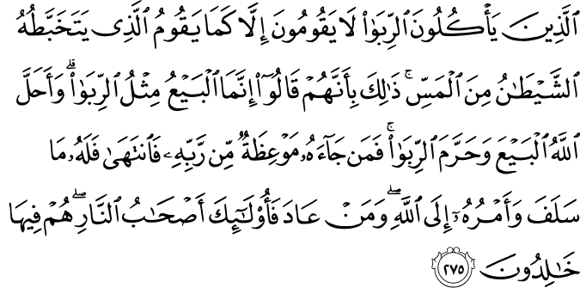
Those who exact usury will not stand but like one deranged by the Devil’s touch. That is because they say, ‘Trade is just like usury.’ While Allah has allowed trade and forbidden usury. Whoever, on receiving advice from his Lord, relinquishes [usury], shall keep [the gains of] what is past, and his matter shall rest with Allah. As for those who resume, they shall be the inmates of the Fire and they shall remain in it [forever].
The above verse first, approves and legalizes exchange and trade (al-bay), while encouraging risk-sharing and equity-based transactions (investment operations) such as Musharakah and Mudharabah and promoting entrepreneurship. Second, it disapproves and prohibits the payment or receipt of interest (riba/usury) and the involvement in any interest-related transactions.
Similarly in another verse, it is prohibited to consume illegally the properties of another without due consent. It is stated thus:
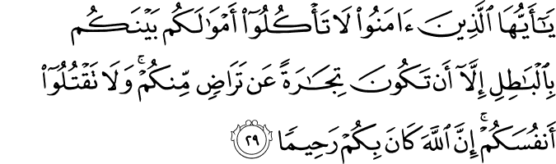

O you who have believed, do not consume one another's wealth unjustly but only [in lawful] business by mutual consent. And do not kill yourselves [or one another]. Indeed, Allah is to you ever Merciful.
Furthermore, the dalil used in determining the benchmark to be used by some of the indices which are placed at 30% and 33% in some quarters is found in the hadith below:
I became seriously ill at Mecca and the Prophet came to visit me. I said, “O Allah’s Messenger! I shall leave behind me a good fortune, but my heir is my only daughter; shall I bequeath two third of my property to be spent in charity and leave one-third (for my heir)?” He said, “No.” I said, “Shall I bequeath half and leave half?” He said, “No.” I said, “Shall I bequeath one-third and leave two-thirds?” He said, “One-third and one-third are much.
In addition, about ruling on the permissibility of investing in primary assets, the following hadith are instructive to note:
When a person buys a palm grove after pollination, then the fruit is for the seller, unless the buyer stipulates this too” (Hadith No.2204, Imam Bukhari). “When a person buys a slave, who has wealth, then the wealth is for the seller unless the buyer stipulates this too”.
Similarly, granting of loans without restriction is allowed based on the evidence of the hadith narrated by Anas bin Malik stated below:
On the night on which I was taken on the Night Journey (Isra), I saw written at the gate of Paradise: 'Charity brings a tenfold reward and a loan brings an eighteen-fold reward.' I said: 'O Jibril! Why is a loan better than charity?' He said: 'Because the beggar asks when he has something, but the one who asks for a loan does so only because he is in need.
Furthermore, the permissibility of allowing Muslims to invest in companies with mixed activities can be deduced from several al-Qawāʿid al-fiqhīyah (Islamic legal maxims) such as al- ḍarar yuzāl ‘harm must be eliminated’; al-mashaqqah tajlib al-taysīr ‘hardship begets facility’; and al-ḍarūrāt tubīḥ almaḥẓūrā ‘necessities make forbidden things permissible.
From the perspective of the Interviewees, Islam allows investment in mixed companies if there are no other options. According to Interviewee D, Islam will not leave Muslims with no options because Islam is not that strict. He emphasized the permissibility of banking with conventional banks before the advent of Islamic banks in Nigeria.

4.5 Proposed Shari’ah Screening Model/Case Study
The Nigerian situation requires a screening methodology that will be simple yet effective to achieve the shari’ah screening objective. Thus, a business screen state model is hereby proposed.
Figure: Business screen state model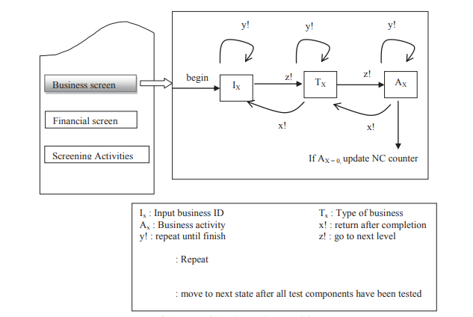
Source: (Noor Latiffah Adam and Nordin Abu Bakar, 2014)
By implementing a classification system like GIS® or ICB, business screen practice has been automated in some areas. The issue is that the business can only be classified under one code. Multiple categorization codes can be assigned to a corporate entity using the approach. The model will keep track of the sort of business and its ID. Due to the possibility that a firm may have many core businesses, a repetition during the type of business identification is required. Once all associated commercial activity has been screened, the loop is closed. A certain subsidiary's business operations will thereafter be continuously monitored. Up until every aspect of the business, activity has been examined, the repetition will continue. However, creating a classification system is difficult because of this.
It is further necessary to examine a company's financial operations to determine the extent of its participation in illegal secondary activities. As a result, Muslim investors must comprehend two parts of a company's business conduct: a) its general commercial activities, and b) its financial operations. While the second is dealt with under "Quantitative or Financial Screening," the first is covered under "Sector and Activity Based Screening." Quantitative or financial screening mostly uses two methods: The first step is to make sure a company's primary assets are not primarily cash or assets related to cash. Trading shares of a corporation whose primary assets are cash amounts to exchanging cash at a discount or premium which amounts to the sale of debt and this prohibited
In addition, sector screening is dedicated to doing screening using business industry categorization; nevertheless, it is not sufficient. Hence, the financial screening requires reporting the ratios so that earlier sector analysis remains satisfactory to be shari’ah-compliant and otherwise. Likewise, numerous methods make a report, yielding diverse types of data, and some of the reports may not separate the revenue from riba making, which makes financial screening essential. Those aspects need a wary calculation because earning may be sinful and thus would be subject to purification. Nevertheless, alongside in-depth manual research, the automated system has been prescribed to do the screening.
Figure 4: Overview of Financial Screening Norms
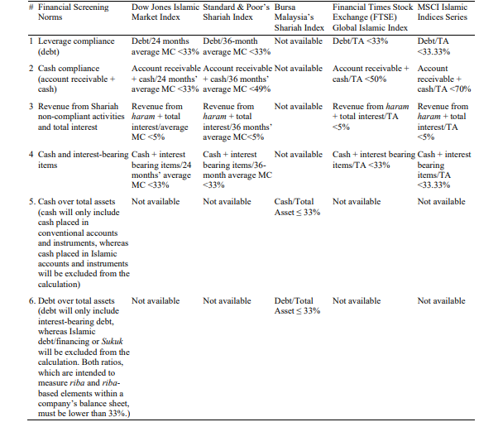
It is important to note that just screening for shari’ah compliance is not the only step required in shari’ah screening. There is a further step in ensuring that the non-permissible or non-halal profits portion of the entire profit made by such a company engaged in mixed activities needs to be cleaned. This is known as the purifying process. Muslims involved in such companies need to ensure they purify the profits by segmenting the part that is non-halal and giving it out to charity.

- CONCLUSION/RECOMMENDATION/FUTURE RESEARCH
The paper reviewed some important literature on the subject of discourse pointing out the gap in the literature and justifying the need for shari’ah screening of businesses and companies in Nigeria. Thereafter, the research methodology used was succinctly described, giving details of the interview conducted. The discussion of results and finding section discusses equity investment in Islam, businesses and companies’ operations in Nigeria, the Practice of Shari’ah screening in other jurisdictions, the dalil for shari’ah screening and finally proposing a shari’ah screening model for use in the Nigerian context.
The paper thus finds that while it is true that Nigeria is in need of a shari’ah screening model and index that will effectively screen companies for shari’ah compliance because of the teeming Muslim investors, the practitioners and stakeholders are not fully aware of how this works. This invariably means that there is little interest in ascertaining the shari’ah compliance nature of a company by would-be investors before they invest in stocks of companies which could be largely attributed to their lack of knowledge of the need for shari’ah compliance of such businesses and investments.
Therefore, based on the above findings from the interview sessions, several recommendations are hereby suggested for implementation:
- Need for Awareness: There is a need to inform Muslim Investors of the need to ensure that they invest in only shari’ah-compliant stocks and businesses. This can be undertaken with proper education using different outlets such as both print and social media platforms, organizing seminars and workshops, talk shows, etc. this can be carried by the relevant department of the Central Bank of Nigeria in collaboration with some consulting firms and NGOs for proper implementation.
- Profit/Income Purification: Just as has been discussed in the body of this paper, there is the need to ensure strict compliance with profit purification especially profits from non-permissible income made by the company. This can be effectively done by employing the use of Islamic social finance instruments such as Zakat, waqf, etc. it is further recommended that a shari’ah committee be set up that will ensure strict compliance with this.
- Shari’ah reporting: As a corollary to the above recommendation, shari’ah reporting should be made compulsory for companies and businesses to ensure an effective shari’ah screening because all necessary information needs to be available for a seamless screening process. The purification of the profit/income process also needs to be adequately reported.
- Establishment of a Shari’ah index that will screen businesses and companies and would effectively list the shari’ah-compliant companies on their website for easy access by Muslim Investors whenever they are ready to invest. This will go a long way in ensuring that Muslims only invest in Shari’ah-compliant stocks.
Finally, the implication of this paper for future research is for a proper review and analysis of the Shari’ah index when this is finally established and also a detailed analysis of the screening methodology being employed. In addition, there could be an assessment of the level of compliance and accessibility of Muslim Investors with the information made available by the shari’ah index so established on their website.

REFERENCES
AAOIFI. (2015). Shari’ah Standards. Manama: Accounting and Auditing Organization for
Islamic Financial Institutions
Ayedh, A.M.A. Shaharuddin, A. & Kamaruddin, M.I.H, (2019), Shariah Screening
Methodology: Does It ‘Really’ Shariah Compliance? IQTISHADIA Vol. 12 (2) 2019
PP. 144-172 P-ISSN: 1979 - 0724 E-ISSN: 2502 – 3993 DOI :10.21043/iqtishadia.
12i2.5573
Abu Zaharah, M. (1997), “Usul al-fiqh”, Cairo: Dar Al-Fikr Al- ‘Arabi
Al-Raysuni, A. (1992), Nazariyat Al-Maqasid ‘Inda Al-Imam Al-Shatibi, International
Institute of Islamic Thought, Herndon.
Dow Jones. (2013). Dow Jones Islamic Market Indices: Overview. Retrieved from
http://www.djindexes.com/islamicmarket/
Zandi, G., Abdul Razak, D. & Hussin, N.U “Stock Market Screening: An Analogical Study
on Conventional and Shariah-Compliant Stock Markets Asian Social Science” Vol.
10, No. 22; 2014 ISSN 1911-2017 E-ISSN 1911-2025 Published by Canadian Center
of Science and Education pp 270-279
Habib, F. and Ahmad, A.U.F. (2017), “Revisiting the AAOIFI Shariah standards’ stock
screening criteria”, International Journal of Business & Society, Vol. 18
Htay, S.N.N., Abedeen, Z. and Salman, S.A. (2013), “Towards standardization of Shari’ah
screening norms and practices”, International Journal of Humanities and Social
Science Invention, Vol. 2 No. 11, pp. 23–30.
Mason, J. (2002). “Qualitative Researching” Thousand Oaks, California: Sage Publications
Adam, N.L & Abu Bakar, N. “Shariah Screening Process in Malaysia’’ Procedia – Social
and Behavioral Sciences Elsevier B.V., Vol. 121 No. September (2014) 113 – 123
Yildirima, R and Ilhanb, B., (2018). “Shari'ah Screening Methodology - New Shari'ah
Compliant Approach” Journal of Islamic Economics, Banking and Finance, Vol. 14,
No. 1, January-March, 2018 pp 168-191
Buerhan, S and Adam, A. (July 1, 2016) “The Legal Maxims of Islamic Law (Excluding Five
Leading Legal Maxims) and Their Applications in Islamic Finance”
Journal of King Abdulaziz University: Islamic Economics, Vol. 29, No. 2, 2016,
Tanin, T.I., Ahmad, A.U.F. and Muneeza, A. (2021), Shariah-compliant equities and Shariah
screening: Need for convergence of ethical screening of stocks with Shariah
screening, International Journal of Emerging Markets, Vol. ahead-of-print, No.
ahead-ofprint. https://doi.org/10.1108/IJOEM-09-2020-1041
Derigs, U. & Marzban, S. “Review and analysis of current Shariah-compliant equity
screening practices” International Journal of Islamic and Middle Eastern Finance
and Management · November 2008 DOI: 10.1108/17538390810919600 · Source:
RePEc Available at SSRN: https://ssrn.com/abstract=3062121
Yin, R. K. (2014). Case Study Research: Design and Methods. Thousand Oaks,
California: Sage Publications

Surah al-Baqarah, Qur’an 2: 168
Resolution #4, Session #14, Islamic Fiqh Council, (2006)
Gholamreza Zandi, Dzuljastri Abdul Razak & Nur Hidayah Hussin, “Stock Market Screening: An Analogical Study on Conventional and Shariah-Compliant Stock Markets Asian Social Science”, Vol. 10, No. 22; 2014 ISSN 1911-2017 E-ISSN 1911-2025 Published by Canadian Center of Science and Education pp 270-279
Abdullah Mohammed Ahmed Ayedh, Amir Shaharuddin, Muhammad Iqmal Hisham Kamaruddin, “Shariah Screening Methodology: Does It ‘Really’ Shariah Compliance?” IQTISHADIA Vol. 12 (2) 2019 PP. 144-172 P-ISSN: 1979 - 0724 E-ISSN: 2502 – 3993 DOI :10.21043/iqtishadia. v12i2.5573
Ramazan Yildirima and Bilal Ilhanb, “Shari'ah Screening Methodology - New Shari'ah Compliant Approach”Journal of Islamic Economics, Banking and Finance, Vol. 14, No. 1, January-March, (2018) pp 168-191
Tauhidul Islam Tanin, Abu Umar Faruq Ahmad, and Aishath Muneeza, “Shariah-compliant equities and Shariah screening: Need for convergence of ethical screening of stocks with Shariah screening”, International Journal of Emerging Markets, (2021) Vol. ahead-of-print, No. ahead-ofprint. https://doi.org/10.1108/IJOEM-09-2020-1041
Noor Latiffah Adam and Nordin Abu Bakar, ‘’Shariah Screening Process in Malaysia’’ Procedia - Social and Behavioral Sciences Elsevier B.V., Vol. 121 No. September (2014) 113 – 123
Ulrich Derigs and Shehab Marzban, “Review and analysis of current Shariah-compliant equity screening practices” International Journal of Islamic and Middle Eastern Finance and Management · November 2008 DOI: 10.1108/17538390810919600 · Source: RePEc Available at SSRN: https://ssrn.com/abstract=3062121
Robert K. Yin, Case Study Research: Design and Methods. (Thousand Oaks, California: Sage Publications, 2014).
Jennifer Mason, Qualitative Researching. (Thousand Oaks, California: Sage Publications, 2002)
Robert K. Yin, Case Study Research: Design and Methods. (Thousand Oaks, California: Sage Publications, 2014).
Shariah-Compliant Stocks (i-Stocks) https://www.bursamalaysia.com/trade/our_products_services/islamic_market/bursa_malaysia_i/shariah_compliant_stocks
Ibid.
Abdullah Mohammed Ahmed Ayedh, Amir Shaharuddin, Muhammad Iqmal Hisham Kamaruddin, “Shariah Screening Methodology: Does It ‘Really’ Shariah Compliance? “ IQTISHADIA Vol. 12 (2) 2019 PP. 144-172 P-ISSN: 1979 - 0724 E-ISSN: 2502 – 3993 DOI :10.21043/iqtishadia. v12i2.5573
Sural al-Baqarah, Qur’an 2:275
Sural al-Nisai, Qur’an 4:29
Hadith No.5659, Imam Bukhari
Hadith No.2379, Imam Bukhari
Hadith No.2431, Book 15, Vol.3, Sunan Ibn Majah
Burhan Uluyol & Adam Abdullah, “The Legal Maxims of Islamic Law (Excluding Five Leading Legal Maxims) and Their Applications in Islamic Finance Journal of King Abdulaziz University: Islamic ECONOMICS, Vol. 29, No. 2. 2016

