EXPERIMENTAL MEASUREMENT OF ATTENUATION OF SOBI FM SIGNALS AT VHF ALONG ILORIN JEBBA ROAD, NIGERIA

¹Ajani, A. S.,¹Egebeyale, G. B.,¹Yusuf, O. A., ²Aliu T. O., ³Aremu O. A., ⁴Odeyemi, C. S., ⁵Oyero, O. P.
²Kwara State University, Department of Physics and Materials Science, P.M.B. 1530 Malete, Ilorin, Nigeria.
²Kwara State University, Department of Mathematics and Statistics, P.M.B. 1530 Malete, Ilorin, Nigeria.
³Department of Physics,The Polytechnic, Ibadan P.M.B. 22, UI Post Office, Ibadan, Nigeria

⁴Federal University of Technology P.M.B. 704, Akure, Ondo State, Nigeria.

⁵Department of Basic Sciences, Adeleke University, P.M.B. 250 Ede, Osun State, Nigeria

Correspondence: adegbenro.ajani@kwasu.edu.ng +2348038382370

ABSTRACT
The study of the propagation loss at very high frequency (VHF) band precisely 101.9 MHz (Sobi FM) signals was carried out in this research. It involves Experimental measurement and theoretical calculation using the existing Friis [FA] and Free Space attenuation [FSA] formula to determine the attenuation and the fade margin of 101.9MHz (Sobi FM) signals along Ilorin (Lat 80541; Long 40551E) – Jebba (Lat 90111N; Long 40821E) links, in Nigeria.
The experimental measurement campaign was achieved by using an appropriately designed dipole antenna, using spectrum analyzer to determine the attenuation and the fade margin at regular intervals of two kilometers (2 km) from the base station, up to sixty kilometers (60 km) along the chosen links. The analytical models were obtained in form of polynomial equations for received power, measured attenuation and the fade margin of the signals.
The measured results were compared with the calculated results. The calculated results correlated with the measurements (Correlation coefficient value R2 = 1), but gave deviation when compared with the measurements (Chi-square values equal zero for received power, measured attenuation and the fade margin). The variance of the results for the existing formula with the measurements were adjudged to hills, valleys, trees and bends along the links. The highest value of the fade margin obtained (75.89 dB) has not exceeded the receiver’s sensitivity of 80 dB, which implies that the radio-signals can be improved, by increasing the height and the power of transmitting antenna.
This research hopes to give information to Sobi FM transmitting station or intending transmission companies on area to improve should there be a need to upgrade or redirecting their transmission signals.
Keywords: Antenna, Attenuation, Power Density, Electromagnetic Wave, Fade Margin.
INTRODUCTION
Attenuation is the reduction in power density of an electromagnetic wave as it propagates through space. The loss of energy suffered by radiation as it passes through matter, especially as a result of absorption or scattering or loss of signal power or amplitude caused during its transmission through a particular medium is generally termed attenuation. Attenuation may be due to certain effects such as free space loss, reflection, diffraction, refraction, absorption, aperture-medium coupling loss. Attenuation could also be influenced by terrain, contours, environment (urban or rural, vegetation and foliage), propagation medium, the distance between the transmitting and the receiving stations, and height and location of antenna (Rhodes, 2001).
The ratio of received power to transmitted power is called path loss. Path loss is one of the factors that cause attenuation. In path loss radio waves become weaker as they move away from the transmitter. Line of Sight (LOS) paths at Very High Frequency (VHF)(30-300MHz) and Ultra High Frequency (UHF)(300-3000MHz) require relatively little power since the total path loss at the radio horizon is only about 25 decibels (dB) greater than the path loss over the same distance in free space, where there is no obstruction (Poole, 2010).However, the reflected waves may reduce or increase attenuation. Often, it is possible to communicate beyond the normal LOS distance by exploiting the reflection from a tall building, nearby mountain, or water tower. If the top portion of a structure or hill can be seen readily by both transmitting and receiving antennas, it may be possible to achieve practical communications by directing both antennas toward the point of maximum reflection. If the reflecting object is very large in terms of wavelength, the path loss, including the reflection, can be very low. If a structure or hill exists adjacent to an LOS path, the reflected energy may either add to or subtract from the energy arriving from the direct path. If the reflected energy arrives at the receiving antenna with the same amplitude (strength) as the direct signal, but has the opposite phase, both signals will cancel and communication will be impossible (Rhodes, 2001).
Generally, in the VHF and UHF range, the reflected wave is out of phase (destructive) with respect to the direct wave at vertical angles less than a few degrees above the horizon. However, since the ground is not a perfect conductor, the amplitude of the reflected wave seldom approaches that of the direct wave. Thus, even though the two arrive out of phase, complete cancellation does not occur. Some improvement may result from using vertical polarization rather than horizontal polarization (Rhodes, 2001).
Diffraction is another factor that causes attenuation of radio signals. It is emphasized, however, that the energy decays very rapidly as the angle of propagation departs from the straight LOS path. Typically, a diffracted signal may undergo a reduction of 30 to 40 dB by being bent only 7.5metres by a mountain ridge. The actual amount of diffracted signal depends on the shape of the surface, the frequency, the diffraction angle and many other factors. It is sufficient to say that there are times when the use of diffraction becomes practical as a means for communicating in the VHF and UHF over long distances (Aboaba, 2003).
Furthermore, tropospheric refraction also causes attenuation in which refraction is the bending of a wave as it passes through air layers of different density (refractive index). In semitropical regions, a layer of air of 5 to 100 meters thick with distinct characteristics may form close to the ground as a result of temperature inversion. For example, on an unusually warm day after a rainy spell, the sun may heat up the ground and create a layer of warm, moist air. After sunset, the air a few meters above the ground will cool very rapidly while the moisture in the air close to the ground serves as a blanket for the remaining heat. After a few hours, a sizable difference in temperature may exist between the air near the ground and the air at a height of 10 to 20 meters, resulting in a marked difference in air pressure. Thus, the air near the ground is considerably denser than the air higher up (Barilla et al, 2011).
This condition may exist over an area of several hundred kilometers or over a long area of land near a sea cost. When such an air mass forms, it usually remains stable until dawn, when the ground begins to cool and the temperature inversion ends. When a VHF or UHF radio wave is launched within such air mass, it may bend or become trapped (forced to follow the inversion layer). This layer then acts as a duct between the transmitting antenna and a distant receiving site. The effects of such ducting can be seen frequently during the year in certain locations where TV or VHF FM stations are received over paths of several hundred kilometers. The total path loss within such a duct is usually very low and may exceed the free space loss by only a few decibels. It is also possible to communicate over long distances by means of tropospheric scatter (Rhodes, 2001; Ulaby, 2010).
Noise is another factor that causes attenuation; it consists of all undesired radio signals, manmade or natural. Noise masks and degrades useful information reception. The radio signal’s strength is of little importance if the signal power is greater than the received noise power. This is why signal to noise ratio is the most important quantity in a receiving system. Increasing receiver amplification cannot improve the signal to noise ratio since both signal and noise will be amplified equally and signal to noise ratio will remain unchanged. Normally, receivers have more than enough amplification (Watt and Maxwell, 2010). Noise can be classified into two, namely natural and manmade noise (Rhodes, 2001; Shoewu and Edeko, 2011).
METHOD
The following procedures were taken in order to determine the attenuation values (measured and calculated) and the fade margin of Sobi 101.9MHz radio frequency signals along Ilorin-Jebba link.
The instruments used to carry out the field work were listed as follows:
i Spectrum Analyzer: This measure the magnitude of an input signal versus frequency within the full frequency range of the instrument. The primary use is to measure the power of the spectrum of known and unknown signals. A GSP 730 spectrum analyzer ranging from 150 KHz – 3GHz was adopted in this experiment to measure the peak radiated power received $P_{R}$($dBm)$ from frequency 101.9MHz.
ii Half-Wave Dipole Antenna: A half wave dipole was used because it is very useful as a mobile antenna and the car body can be used as conducting plane. The antenna was connected to the spectrum analyzer to pick the signal being transmitted from 101.9MHz broadcasting station.
iii Inverter System: A 2KVA inverter was used to power the spectrum analyzer to prevent interference.
iv Generator: A 1.5KVA Elepaq generator was employed as a backup for the inverter system
Allinstruments were coupled together and the overall set up of the instruments used to carry out the field work are shown in figure 1

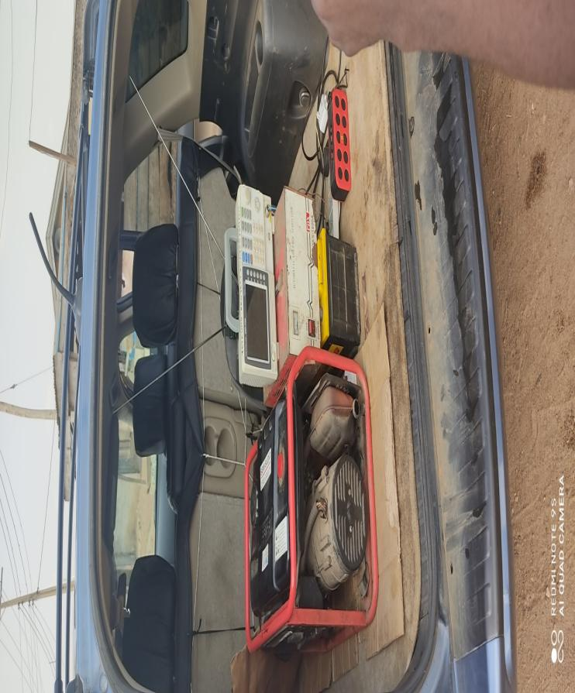
Figure1:Set up of the instruments used for the field work

Data Acquisition
Sobi FM is operating on frequency 101.9MHz, with actual radiated power of 2.5kW from the transmitting antenna (100m high ), using a transmitter rated 5kW. In this study, both experiment and calculated method were employed, the field work was carried out to obtained the actual power received from Sobi FM station to Jebba axis over a distance of sixty kilometers (60km) at interval of two kilometers (2km), a Half-Walf dipole antenna well connected with spectrum analyzer was used to pick the received power.
Considering 2.5kW power directly radiated ($P_{R}$) from the transmitting antenna, transmission line loss $L_{T}$ between the transmitter and the transmitting antenna $T_{A}$ is negligible. Also, since the length of cable connecting the receiving antenna to the receiver is about$1.44m$, the line loss $L_{R}$ between the spectrum analyzer (receiver) and the receiving antenna $R_{A}$ is negligible. Therefore, the received power is given in equation (1) (Grayson, 2012):
$P_{R}=P_{T}+G_{T}+G_{R}-32.4-20logf-20logd$ dBm (1)
$P_{T}$ = 2.5kW $(dBm),G_{T}$ = 9.54dBi, $G_{R}$ = 1.76 dBi, $f = 101.9MHz$, and $d$ varied from 2km to 60km (coverage area of the transmitter) are substituted into equation (1) to compute $P_{R}$ in equation (2). $P_{R}$ obtained were converted to Watt (W) and $P_{T}$ = 2500W are substituted in to equation (2) to yield the Friis Attenuation (FA) of the radio waves (Grayson, 2012). equation (3) is computed to yield the Free Space Attenuation (FSA) of the radio waves.
Experimental Measurements
The experimental measurements were carried out by moving the suitably designed receiving dipole antenna well connected (matched) to the receiver system (spectrum analyzer) to measure the signal power $(dBm)$ received at 2km interval from the transmitting antenna up to 60km along possible line of sight (LOS). 2KVA inverter was used to power the analyzer to prevent interference, while the car radio was used to monitor the audio signals transmitted. The signal power $P_{R}$ received in $dBm$ is converted to Watt shown in table1 using equation (3).
$P_{R}={10}^{dBm/10}(mW)$ (2)
Calculated values of Attenuation using Existing formula
To calculate the attenuation of Sobi FM (10.9MHz) along Ilorin-Jebba link.
The formula stated in equation (3) was applied:
Attenuation (A) is defined as the reduction in magnitude of a radio frequency signal from the transmitting station on passing along any transmission path (AbdAlaziz 2011, Kia 2000). It is directly proportional to the frequency and distance of transmission. The general formula is given in equation 3 (Sanjaya and Jingsu, 2004):
$A\left(dB\right)=10 \log_{10}\left[\frac{P_{r}}{P_{t}}\right]$ (3)
$A$: is the attenuation in decibel, $P_{r}$ : is the power received by receiver at a particular distance
$P_{t}$: is the power transmitted from the station
2.2.3 Derivation of the new formula from the existing formula
Formulas for calculations of free space transmission power received and loss (path loss, FSL) are presented by considering a transmitter with power $P_{T}$coupled to an antenna which radiates equally in all directions (Kai ,2000; Kraus et al., 2002 and Balanis, 2005). The (LOS) free space path loss is calculated, having considered the scattering effects of reflection, refraction and diffraction along the radio free space communication links as suggested by the Huygens’ Principle. At a distance d from the transmitter, the radiated power is distributed uniformly over an area of 4πd² (i.e. the surface area of a sphere of radius d), so that the power flux density (Balanis, 2005), S is given as:
$S=\frac{P_{T}}{4πd^{2}}$ Watt/$m^{2}$ (4)
If the capture area, or effective aperture of this antenna is$A_{R}$, then the power $P_{R}$which can be delivered to the receiver (assuming no mismatch or feed line losses) is simply given as equation (5) (Grayson, 2012):
$P_{R}$=S$A_{R}$ Watt (5)
For the hypothetical isotropic receiving antenna (Kraus, 1988),
$A_{R}=\frac{λ^{2}}{4π}$ $m^{2}$ (6)
Combining equation (64 and (5) into (6), yield:
${ P}_{R}= P_{T}{\left(\frac{λ}{4πd}\right)}^{2}$ Watt (7)
The free space path loss between the isotropic antennas is $P_{R}$/$P_{T}, s$ubstituting $λ$= c/f (where c, is the speed of light~3.0$×$10⁸ms-¹) into equation (7) to get:
$FSL={\left(\frac{4π}{c}\right)}^{2}f^{2}d^{2}$ (8)
When equation (8) is expressed logarithmically, it yields:
$FSL(dB) =32.4+20logf+20logd$ (9)
Substituting equation (9) into the Friis transmission formula which is given by Prasad et al., (2006); Gurung, and Zhao, (2011) and s expressed logarithmically, it yields:
$P_{R}=P_{T}-32.4+20logf+20logd+G_{T}+G_{R}-L_{T}-L_{R}$ dBm (10)
Where, f = resonant frequency in MHz, d = distance covered by the radio waves in km, $P_{T}$= transmitter power output in dBm, $G_{T}$and $G_{R}$= transmit and receive antennas gain in dBi respectively, $L_{T}$= transmission line lose between transmitter and transmit antenna in dB,$L_{R}$= transmission line loss between receiver input and receive antenna in dB.
Now, instead of finding the ratio: $P_{T}$/$P_{R}$, from the equation 4, let us find the ratio $P_{R}$/$P_{T}$, which yields:
$\frac{P_{R}}{P_{T}}= {\left(\frac{c}{4πfd}\right)}^{2}$ (11)
When equation (8) is substituted into equation (1), it yields a standard free space attenuation formula [FSA]:
$A=147.5571-20\log_{10}f-20\log_{10}d$ dB (12)
Where, f is resonant frequency in Hz, d is distance covered by the radio waves in meters.
Fade Margin
Fading is defined as the variation of the strength of a received radio carrier signal due to atmospheric changes and/or ground and water reflections in the propagation path. Four fading types are considered while planning links. They are all dependent on path length and are estimated as the probability of exceeding a given (calculated) fade margin (Grayson, 2012).
i Multipath Fading
This is the dominant fading mechanism for frequencies lower than 10GHz. A reflected wave causes a multipath, i.e. when a reflected wave reaches the receiver as the direct wave that travels in a straight line from the transmitter. If the two signals reach in phase, then the signal amplifies. This is called up-fade(Grayson, 2012).
$Upfademax= 10logd – 0.03d \left(dB\right)$ (13)
$d$ is path length in km
If the two waves reach the receiver out of phase they weaken the overall signal, a location where a signal is canceled out by multipath is called null or down fade (Middleton, 2003).
ii Flat fading
This type of fading occurs when frequencies in the channel are equally affected. There is barely noticeable variation of the amplitude of the signal across the channel bandwidth. But, flat fade margin of a link can be improved by using larger antennas, a higher-power microwave transmitter, lower-loss feed line and splitting a longer path into two shorter hops (Middleton, 2003).
iii Frequency-selective fading
There are amplitude and group delay distortions across the channel bandwidth. It affects medium and high capacity radio links ($>32 Mbps)$. The sensitivity of digital radio equipment to frequency-selective fading can be described by the signature curve of the equipment. This curve can be used to calculate the Dispersive Fade Margin (DFM)(Middleton, 2003).
$DFM= 17.6-10log[2(∆f)e-B/3.8/158.4]dB$ (14)
$∆f$ =signature width of the equipment
B= notch depth of the equipment.
iv Rain Fading
Rain attenuates the signal caused by the scattering and absorption of electromagnetic waves by rain drops. It is significant for long paths ($>$10km). It starts increasing at about 10GHz and for frequencies above 105GHz, rain fading is the dominant fading mechanism. Rain outage increases dramatically with frequency and then with path length (Middleton, 2003; Al-Basheir, Shubair and Shariff, 2006).
v Refraction-Diffraction Fading (K-Type Fading)
Refraction-Diffraction Fading is also known as k-type fading. For low k values, the earth’s surface becomes curved and terrain irregularities, man-made structures and other objects may intercept the Fresnel Zone. For high k values, the Earth’s surface gets close to a plane surface and better LOS (lower antenna height) is obtained. The probability of refraction-diffraction fading is therefore indirectly connected to obstruction attenuation for a given value of Earth – radius factor. Since the Earth-Radius factor is not constant, the probability of refraction-diffraction fading is calculated based on cumulative distributions of the Earth-radius factor (Middleton, 2003).
However, the fade margin of the transmitted frequency signal of 101.9 MHz was calculated from the measured value using the formula in equation 15 (Grayson, 2012).
$FADE MARGIN= Pt(dBm)+Gt(dBm)+Gr(dB)-FSL(dB)-RS(dB)$ (15)
Where, RS= Receiver’s sensitivity=$-$80dB

RESULT AND DISCUSSION
The signal gets attenuated as it propagates through the medium and the longer the distance it travels, the more the attenuation obtained and finally after propagating through a long distance of above 60 km, the signal received getsvery diminished. As the signal travels, it gets attenuated exponentially (Sanjaya and jinsu, 2004; Stutzman and Thiele, 2012).
After measuring and calculating the attention values of radio frequency signals of 101.9 MHz (Sobi FM) along Jebba over a distance of 60 km, the results in Table 1 are stated for the first 20 km obtained. Distance (D) km, with Power Received (PR) dBm and Watt, Power Calculated (PC) in dBm and Watt, Attenuation Measured (AMe) in dB, Friis Attenuation calculated (FAC) in dB, Free Space Attenuation calculated (FSAC) in dB and Fade Margin (FMa) in dB.

Table 1: The Power, Attenuation (Received and Calculated), Fade and Distance (2-20km)
D(km) | PR (dBm) | PR (W) | PC (dBm) | PC (W) | AMe(dB) | FAC (dB) | [FSAC (dB) | FMa  (dB)
2 | -22.26 | 6.31*10⁻⁶ | -4.11 | 3.88*10⁻⁴ | -85.99 | -68.09 | -78.627 | 75.89
4 | -25.70 | 2.69*10⁻⁶ | -10.13 | 9.71*10⁻⁵ | -89.66 | -74.10 | -84.647 | 69.87
6 | -26.92 | 2.03*10⁻⁶ | -13.65 | 4.32*10⁻⁵ | -90.84 | -77.62 | -88.169 | 66.35
8 | -28.70 | 1.35*10⁻⁶ | -16.15 | 2.42*10⁻⁵ | -92.68 | -80.14 | -90.668 | 63.85
10 | -34.20 | 3.80*10⁻⁷ | -18.08 | 1.56*10⁻⁵ | -98.18 | -82.04 | -92.666 | 61.92
12 | -36.4 | 2.29*10⁻⁷ | -19.67 | 1.08*10⁻⁵ | -100.38 | -83.65 | -94.190 | 60.33
14 | -36.4 | 2.29*10⁻⁷ | -21.01 | 7.93*10⁻⁶ | -100.38 | -84.99 | -95.529 | 58.99
16 | -39.70 | 1.07*10⁻⁷ | -22.17 | 6.07*10⁻⁶ | -103.69 | -86.15 | -96.689 | 57.83
18 | -40.01 | 9.98*10⁻⁸ | -23.19 | 4.80*10⁻⁶ | -103.99 | -87.17 | -97.712 | 56.81
20 | -40.08 | 9.98*10⁻⁸ | -24.10 | 3.89*10⁻⁶ | -103.99 | -88.08 | -98.627 | 55.90

Comparison of Calculated Power (Using Friis Formula) and Measured Power
There was a sharp deviation between calculated power received results and measured power received result when chi square and standard deviation were calculated as shown in Table 2 and the plot of power measured and power calculated plotted against distance in Figure2. The deviation maybe due to some factor not consider in the formula like hills, valleys, and forested areas. However, there is a correlation between the two powers because they are function of distance. As the distance increases from the transmitting station, the signal power continues to decrease.
Using the method of least fit on the graph plotted in Figure 2, analytical model in equation (16) was obtained in the form of polynomial equation of second degree from the received power (experimental measured data).
$P(x)=p_{1}x^{n}$+ $p_{2}x^{n-1}+----+p_{n}x+p_{n+1}$ (16)
$P(x)=0.0034x^{2}- 1.0136x-22.269$ (17)
Table 2: Comparison of experimental and calculated values of power received
 | Mean | Std.  Deviation | N | Df | Chi-  Square | Asymp.  Sig | Peareson correlation  Sig.
POWER  MEASURED  (dBin) | -49.465 | 14.651 | 32 | 18 | 13.753a | 309 | 1
POWER  CALCULATED  (dBin) | -25.721 | 7.3854 | 32 | 32 | 000b | 1.000 | 823

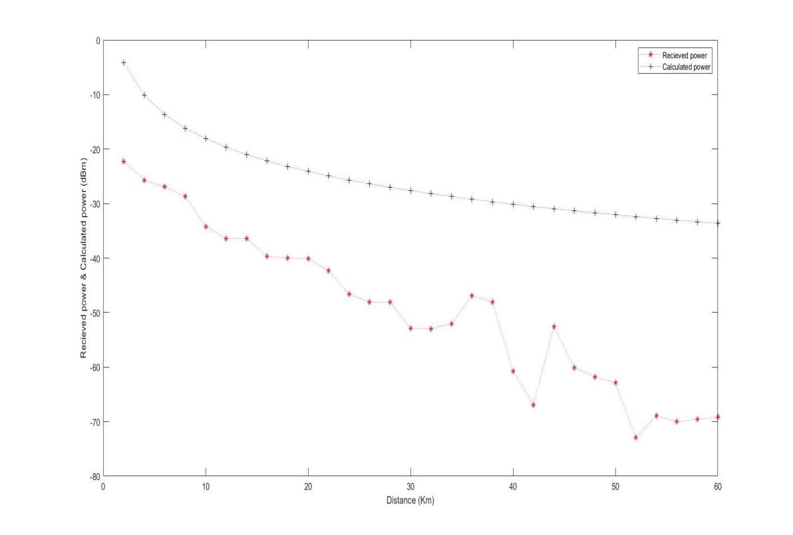
Figure 2: Graph of power measured and power received against distance
Comparison of Calculated and Experimental Values of Attenuation Plotted against Distance
The graph attenuation against distance for experimental values in Figure 3 is not a smooth curve in comparison with calculated values. Also, there were deviations when chi square test, standard deviation and Pearson correlation coefficient was calculated in Table 3. The unsmooth curve and deviations may be due to hills, valleys, trees and bends along the road.
Using the method of least square fit on the graph plotted in Figure 3, analytical model in equation (18) was obtained in the form of polynomial equation of second degree from attenuation measured (experimental measured data).
$A(x)=A_{1}x^{n}$+ $A_{2}x^{n-1}+----+A_{n}x+A_{n+1}$ (18)
$A(x)=0.007x^{2}– 1.140x – 85.513$ (19)

Table 3: Comparison of experimental and calculated values of attenuation
 | Mean | Std.  Deviation | N | Chi-square | Df | Asymp.  Sig | Pearson  Correlation  Sig. | Std  Error of Mean
MEASURED  ATTENUATION(dB) | -112.096 | 13.281 | 32 | 11.563² | 16 | 774 | 1 | 2.424807
CALCULATED  ATTENUATION FA(dB) | -89.694 | 7.383 | 32 | .000^{b} | 31 | 1.000 | .106 | 1.347935
CALCULATED  ATTENUATION FSA(dB) | -100.245 | 7.385 | 32 | .000^{b} | 32 | 1.000 | .101 | 1.348255

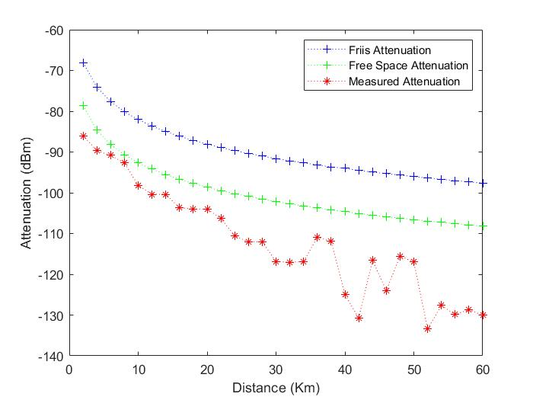
Figure 3: Graph of FA, FSA and Measured attenuation against Distance.
Fade Margin of Sobi Fm Radio signals from Experimental data
Using the method of least square fit on the graph plotted in figure 4, analytical model in equation 20 was obtained in the form of polynomial equation of second degree from fade margin measured (experimental measured data).
$F(x)=F_{1}x^{n}$+ $F_{2}x^{n-1}+----+F_{n}x+F_{n+1}$ (20)
$F(x)= 0.0091x^{2}– 0.9531x + 72.298$ (21)
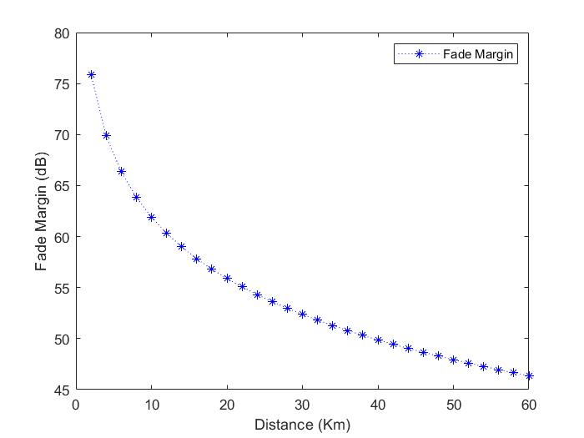
Figure 4: Graph of Fade Margin against Distance.
CONCLUSION
The attenuation values (measured and calculated) and the fade margin of Sobi 101.9MHz radio frequencysignals along Ilorin-Jebba link were determined.The measured results were compared with the calculated result using the existing Friis formula and derived Free Space attenuation formula. The existing model correlated very well with the measurement, Chi-square gives value of zero. The inaccuracy of the existing formula may be due to valleys, high rising buildings and treesalong the road. However, the radio signal were well received between the space margins calculated, and at times the links goes down to the valleys and bends along the road. Repeater stations are recommended to be installed for effective transmission and for wider coverage.

REFERENCES
Aboaba, O.A. (2003). Experimental Studies in VHF/UHF frequencies in A Tropical Climate, XV URSI 2003, XXVLth General Assembly Toronto, Canada. Pp 375.
AbdAlaziz, W. (2011). Design and Development of Multi-Band Microstrip Rectangular Fractal Antenna for Wireless Applications. 10.13140/RG.2.2.21507.45606.
Al-Basheir M.S., Shubair, R.M. and Shariff, S.M. (2006). Measurement and Analysis for signal Attention through Date Palm Trees at 2.1 GHz Frequency, Sudan Engineering Society Journal, 52(45):17 – 22.
Balanis, C. (2005). Antenna Theory. 3rd Edition, ISBN 0-471-66782-X, John Wiley & Sons Ltd., USA
Barilla, T., Barwick, S. and Saltzberg, D. (2011). Ross Ice Shelf (Antarctica) in Situ Radio, Frequency Attenuation. Journal of Glaciology, 57(201):61-66.
Csurgai, H. and Bito, J. (2004). Fog Attenuation on V-Band Terrestrial Radio and a low Cost Measurement set-up. Budapest University of Technology and Economics. Department of
Gurung, S. and Zhao, J. (2011) Attenuation of microwave Signal and its impact on Communication System. Retrieved on September 14, 2011 from http: //www.sanjayagurung.coms
Grayson, C. (2012). Formula for calculating Fade Margin retrieved January 2021, from www.ehow.comm
Kai, C. (2000). RF and Microwave Wireless Systems. ISBN: 0-47135199-7, John Willey and Sons Inc., New York.
Kraus J. D, Marhefka, R. J., Muuk, B. A., Lehto, A., Vainikainen, P., Newman, E. H. and Walker, C. (2002). Antennas for All Applications. Third Edition, ISBN: 0-07-232103-2, McGrawHill, USA.
Lehpaner, H. (2010). Microwave Transmission Networks; planning, Design and Deployment, retrieved, January 2021 from www.ehow.coom.
Lee, (1998). Mobile Communications Engineering: Theory and Applications. McGraw-Hill, USA.
Middleton, J. (2003). The propagation aspects of broadcasting at VHF and UHF, in propagation of Radio Waves. 2nd edition, The Institute of Electrical Engineer London, UK,pp.253-255.
Prasad, M., Rama, Rao, T., Ahmad, I. and Paul, K. (2006). Investigation of VHF signals in bands I AND II in southern India and model comparisons. Indian Journal of Radio and Space Physics. 35:198 - 205.
Poole, I. (2010). Radio Signal Pathloss retrieved December 2011, from Radio Electonics.com.
Rhodes, J.E. (2001). Basic Antenna Handbook, received November 2009 from www.doctrine.quatico.usmc.
Sanjaya, G. and Jinhsu, Z. (2004). Attenuation of Microwave Signal and its impacts on Communication System. Department of Electrical Engineering, College of Engineering University of North Texas page 1-10.
Shoewu, O. and Edeko, F.O.(2011). Microwave Signal Attenuation at 7.2GHz in rain and hamattan Wheather,American Journal of Scientific and Industrial Research http://www.scihub.org/AJSIR-SSN:2153-649X
Stutzman, W.L. and Thiele, G.A. (2012). Antenna Theory and Design. 3rd Edition, John Wiley and Sons, Hoboken.
Ulaby, F., Michielssen, E. and Ravaioli, U. (2010). Fundamental of Applied Electromagnetics. 6th Edition, Prentice Hall.

