Ilorin Linguistic Landscape: A Case for Yoruba Study Abroad in a Multilingual and Multicultural Context

Kazeem K. Sanuth, Indian University, Bloomington, Hafsat O. Olawuyi, Kwara State University, Adebola A. Isaiah, Kwara State University

Abstract
This paper examines the potential of Ilorin, located in the North Central of Nigeria as a site for Yoruba language study abroad programs. While cities like Ibadan and Ife are typically favored for Yoruba pedagogy, the paper argues that Ilorin's unique linguistic landscape and multicultural environment present similar immersive language learning opportunities to cities in South-West Nigeria. Drawing on the conceptual insight of Linguistic Landscape (Landry & Bourhis, 1997), the paper contends that Ilorin's multilingual environment, featuring Yoruba alongside English, Arabic, and other Nigerian languages, can provide students with a nuanced understanding of Yoruba language and culture within a broader Nigerian context.

Keywords: Linguistic Landscape; Study Abroad; Multilingualism; Learning context; immersion site.
Introduction
Language study abroad programs have traditionally been viewed as ideal contexts for language immersion and acquisition. This perception rests on the belief that immersion in a purely monolingual environment of the target language offers learning opportunities far beyond what a traditional classroom can provide. As a result, language study abroad programs are often located in contexts where the target language is predominantly spoken as a “native” language. This is the case for the Yoruba language program in Nigeria, which is situated in cities like Ibadan and other cities in Southwest Nigeria, where Yoruba is the predominantly spoken indigenous language.
Recent research, however, challenges the popular assumption that study abroad sites provide a purely monolingual environment. Students often expect study abroad to offer complete immersion in the target language, but the reality is far more complex and multilingual (Kinginger, 2013). Many study abroad locations are inherently plurilingual environments where multiple languages coexist and are used strategically in different contexts (Canagarajah, 2013). Research on U.S. students studying Yoruba in Nigeria, as described by Mori and Sanuth (2018), illustrates this complexity. Their study revealed that some learners expressed frustration with the lack of a monolingual immersion experience, having expected a purely Yoruba-speaking environment. This expectation likely stems from dominant monolingual ideologies in U.S. language teaching.
The reality of the linguistic landscape in the Yoruba language study abroad sites is far more diverse and complex. So, the linguistic landscape of Ilorin, a city located in North-Central Nigeria, presents an interesting case study for Yoruba language study abroad programs. Yoruba is one of the main languages spoken in Kwara State, Nigeria, along with Nupe, Fulani, and Baruba. Kwara State has 16 local government areas, and Yoruba is spoken in several of them like Ilorin East, Ilorin South, Ilorin West, Offa, etc. The linguistic landscape of Ilorin, Kwara State, reflects the region's rich multilingual and multicultural heritage.
This linguistic diversity is a common feature of many West African communities, including those in the Southwest region where Yoruba is the dominant language. While a large portion of Ilorin's population speaks Yoruba, the city is situated in a region where multiple languages coexist, creating a multilingual and multicultural environment. The city's historical position as a meeting point of Yoruba, Fulani, and Hausa cultures has created a unique dialect of Yoruba, sometimes referred to as "Ilorin Yoruba" (Lamidi & Aboh, 2011). This local Yoruba variant could offer students practical language skills in contrast to the academic, textbook versions they learn in classrooms.
Research Goal
This research article presents our exploration of the linguistic landscape of Ilorin and its implications for Yoruba language study abroad programs. The study is premised on the assumption that the physical location in study abroad programs is multifaceted and crucial for language acquisition and cultural immersion. There are other vital elements of study abroad: Instruction is critical for providing structured learning opportunities (Kinginger, 2009), while human encounters and interactions facilitate language practice and cultural understanding (DeKeyser, 2007). Cultural adaptation, which occurs over time through exposure to local customs and ways of life, is also a significant aspect of the study abroad experience (Gillespie, 2002). Additionally, audiovisual resources are also vital to study abroad. However, this paper focuses on the physical space of study abroad, operationalized by the linguistic landscape, which is particularly relevant in a postcolonial nation like Nigeria.
The Yoruba study abroad program is situated in a multilingual and multicultural context, which plays a significant role in shaping the learning experience. The linguistic landscape of the host country, including the local language, cultural practices, and social norms, influences how students interact with the community and engage with the language (Shohamy & Gorter, 2009). By examining the Ilorin’s multilingual and multicultural contexts, the study draws a connection to the linguistic diversity in existing sites of existing Yoruba language study abroad programs.
Analysis of the study is guided by the following research questions: (1) What is the linguistic landscape of Ilorin, and how does it compare to the linguistic landscape of other Yoruba-speaking cities in Southwest Nigeria where existing Yoruba language study abroad programs are situated? (2) How can Yoruba language study abroad programs adapt to the linguistic diversity found in cities like Ilorin to provide a more inclusive and enriching learning experience for students? The results of this study can help improve the way Yoruba language study abroad programs are designed and carried out. By gaining a better understanding of the linguistic diversity in cities like Ilorin, program developers can create more inclusive and effective learning experiences for students. This will not only enhance the student's language acquisition but also deepen their appreciation for the cultural contexts in which Yoruba is used in contemporary West African societies.

The Yoruba Language Study Abroad Program in Nigeria
The Yoruba language study abroad program in Nigeria is designed to offer foreign learners the opportunity to immerse themselves in Yoruba among native speakers. While there are many individualized Yoruba learning arrangements, there are very few documented institutionalized Yoruba study abroad programs in Nigeria. The most recognized program is a summer initiative that provides American college and university students the chance to learn Yoruba in Nigeria. Known as the Fulbright-Hays Yoruba Group Project Abroad (GPA), this annual eight-week intensive program is designed to provide participants with a comprehensive and immersive Yoruba language and cultural experience. The program aims to train participants in advanced Yoruba proficiency, based on the American Council on the Teaching of Foreign Languages (ACTFL) rating scale.
The GPA program is regularly hosted at the University of Ibadan in Ibadan, Nigeria, located in the South-West region of the country. The program has also been previously hosted at Obafemi Awolowo University, Ile Ife. To achieve its immersive goals, the program supplements daily classroom instruction with a variety of components, including conversation partners, homestays with host families, weekly outdoor classes, cultural outings, and bi-weekly guest lectures.
With the multilingual and multicultural makeup of the South-West region of Nigeria (Bamgbose, 1994; Adegbija, 2004), the Yoruba Study Abroad, is situated in the context of linguistic diversity (Mori & Sanuth, 2018). Despite the obvious plurilingualism of the Yoruba study abroad site, and the documented challenges of navigating the multilingual context, the Yoruba study abroad program continues to attract students seeking to advance their linguistic and cultural understanding of the language.
Linguistic Landscape as a Critique of Assumptions in Yoruba Study Abroad
The conventional wisdom surrounding study abroad experiences often overlooks the complex linguistic realities of our globalized world. This critique challenges the assumption that study abroad destinations offer monolingual environments conducive to immersion in the target language (Higuchi et al., 2023). Most societies today are multilingual to a varying extent, with multiple languages coexisting and influencing each other in intricate ways (Coleman, 2006).
The assumption that study abroad destinations offer monolingual environments conducive to immersion is often not applicable in Nigeria. Students may find themselves in settings where multiple languages are spoken, which can complicate the language-learning process. For instance, while in the host communities to learn Yoruba, students are more likely to encounter a mix of languages in various settings. The sociolinguistics of globalization further complicates this picture, as English often serves as a lingua franca in many international settings, potentially reducing immersion opportunities in the local language (Brock-Utne, 2003). This global linguistic landscape challenges the idealized view of immersion presented in traditional study abroad narratives.
Recent research suggests that even self-identified monolingual individuals often have more diverse linguistic experiences than previously assumed, including exposure to foreign languages both at home and abroad (Pot et al., 2022). This finding further complicates the traditional view of study abroad as a stark contrast to the presumed monolingual home environment.
The linguistic landscape, or the visual representation of languages in a given environment, can serve as a powerful critique of the assumptions underlying traditional study abroad programs. Recent research on Yoruba study abroad programs in Nigeria has revealed the complex multilingual realities that students often encounter, challenging the idealized view of monolingual immersion. As a result, while study abroad experiences can certainly be valuable, a more nuanced understanding of the complex linguistic landscapes in our globalized world is necessary to accurately assess their potential benefits and challenges.

Linguistic Landscape as a Theoretical Approach
Linguistic Landscape (LL) is a theoretical approach that studies the use of language in public spaces, such as signs, labels, billboards, and graffiti. It examines how languages are used and displayed in a given territory, revealing the linguistic diversity and identity of the area. LL emerged as a significant concept in sociolinguistics with Landry and Bourhis' seminal work in 1997. They defined LL as "the language of public road signs, advertising billboards, street names, place names, commercial shop signs, and public signs on government buildings combines to form the linguistic landscape of a given territory, region, or urban agglomeration" (Landry & Bourhis, 1997, p. 25). This definition emphasizes the visual aspects of language use in public spaces and their contribution to the overall linguistic environment.
The scope of LL research has expanded significantly, encompassing various linguistic displays, including public and private signage, advertisements, street and place names, graffiti, digital displays, and soundscapes (Shohamy & Gorter, 2009). LL studies have been conducted in multilingual cities, rural areas, educational institutions, and online spaces, examining the interplay between language, society, and space. LL provides insights into societal multilingualism, language choices, language hierarchies, contact phenomena, regulations, and literacy aspects. It is closely linked to identity theory, as the linguistic landscape of a city evolves with the collective identity of its inhabitants.
LL provides a valuable tool for understanding the complex relationships between language, society, and space. It offers insights into language policies, social identities, and power dynamics, revealing the linguistic composition, power relations, and cultural identities of communities (Shohamy et al., 2010). LL has been extended to include online environments and digital signage, acknowledging the importance of digital spaces (Ivkovic & Lotherington, 2009). LL is also used as a pedagogical tool for language learning and raising linguistic awareness (Cenoz & Gorter, 2008). Furthermore, LL studies have become an important means of examining language revitalization efforts and the visibility of minoritized languages (Gorter et al., 2012).
A crucial understanding of LL studies that shape our study is that linguistic landscapes are not static entities but dynamic spaces that reflect and shape social realities. This perspective guides our analysis beyond mere description towards a deeper exploration of how language use in public spaces contributes to place-making and reflects broader social dynamics. With our data, we aim to paint a comprehensive picture of Ilorin's linguistic landscape. This analysis will not only document the visible manifestations of multilingualism in which Yoruba prominently participates but also explore how these linguistic choices reflect the educational opportunities for Yoruba language study abroad students.

Linguistic Landscape and Language Learning
The linguistic landscape of a place can serve as a valuable resource for foreign language learning by providing authentic, contextualized exposure to the target language. Cenoz and Gorter (2008) argue that the linguistic landscape can function as an additional source of input in second language acquisition, offering learners opportunities to encounter the language in real-world contexts. By observing and interacting with signs, advertisements, and other written texts in public spaces, language learners can develop their vocabulary, reading comprehension, and cultural awareness (Rowland, 2013). The multimodal nature of linguistic landscapes, which often combine text with images and other semiotic resources, can support learners in making meaning and connections between language and its use in society (Malinowski, 2015). Furthermore, engaging with the linguistic landscape can promote autonomous learning, as students can be encouraged to explore and analyze the language in their surroundings independently, fostering a more active and self-directed approach to language acquisition (Sayer, 2010). Overall, the linguistic landscape offers a rich, accessible, and authentic resource for foreign language learners to supplement their formal language instruction and gain insights into the sociolinguistic realities of the target language community.

Methodology
A typical linguistic landscape analysis examines the presence and use of languages in public spaces, often focusing on signage in the areas. With a focus on Ilorin, where diverse languages and cultures converge, the linguistic landscape offers a rich tapestry for analysis. In our exploration of the Ilorin linguistic landscape for Yoruba Study Abroad, we conducted a street-to-street survey, taking notes and pictures of visible signage, such as posters, sign boards, and billboards that convey public messages. These data, as Blommaert (2010) argues, will guide us to “inquire into how that place is imagined, represented, and enacted by its inhabitants" (p. 63).
When analyzing multilingual displays, several factors merit consideration. Landry and Bourhis (1997) emphasize the importance of language prominence, noting that the order and visibility of languages often reflect official policies or local linguistic dominance. Other crucial aspects include the completeness of translations, the accommodation of different scripts and typographies, cultural sensitivity in translations, and the integration of technology in language displays (Gorter, 2013).
Our analysis draws upon both quantitative and qualitative methods, a mixed-methods approach that has become increasingly common in linguistic landscape studies (Cocq et al., 2020). The quantitative component of our study involves a basic but systematic count of signages in our data pool. While linguistic landscape data around Ilorin are inexhaustible in volume, we captured data that are representative of the predominant sociolinguistic realities. We conducted a systematic count of signs, categorizing them by language (monolingual English, Monolingual Yoruba, other languages, bilingual, or multilingual) and analyzing the relative frequencies of appearance of each language. This data provides a broad overview of language representation across Ilorin's public spaces. However, numbers alone cannot tell the full story of the Ilorin linguistic landscape.
We relied more on the qualitative analysis of the textual content of the signs to enrich our interpretation of signage contents. This involves examining the content and purpose of signs, their visual presentation, and the broader socio-cultural context in which they appear. While our analyses examine the totality of linguistic, visual, and semiotic contents of each signage, we more closely focus on textual contents. To ensure a systematic analysis of the multilingual signage in our data reflecting the complex sociolinguistic dynamics at play, we utilize the four-typology proposed by Mechthild Reh (2004): (1) Duplicating Multilingual Writing: The same message is presented in multiple languages, with no differences in content between the language versions; (2) Fragmentary Multilingualism: Only partial information is provided in each language, with no single language containing the full message; (3) Overlapping Multilingual Writing: The languages used overlap in content, with some information duplicated across languages and some information unique to each language, and (4) Complementary Multilingual Writing: Each language version provides distinct information that complements the others, with no overlap in content.
This comprehensive strategy allows us to not only count and categorize the languages visible in public spaces but also to delve deeper into the socio-cultural context that shapes their presence and use. We pay particular attention to the distinction between "top-down" (official) and "bottom-up" (unofficial) signage, as this can reveal important insights into language policies and grassroots linguistic practices (Backhaus, 2007). By examining how multiple languages are used on physical displays, we seek to gain valuable insights into social dynamics, and the evolving nature of communication in the Ilorin multilingual environments.

Data Analysis: (Target) Linguistic and Cultural Resources in a Multilingual Landscape
The Yoruba-speaking study abroad sites, much like the entire country, are marked by a rich assembly of diverse languages coexisting within its borders. Learners’ pedagogical practices, nonetheless, are channeled to the target linguistic and semiotic resources, with varying levels of outcomes. We argue that the Ilorin public spaces offer similar sociolinguistic conditions, in which Yoruba-prominent multilingualism can offer that target language and cultural experience to learners. This section highlights how multiple languages in this context interact with and influence the everyday practices of the Ilorin public place, creating a unique sociolinguistic environment.

Lopsided Display of English-Medium Signs.
The prevalence of English texts was expected as we explored the data of the Ilorin linguistic landscape, and this is strikingly evident from our signage data analysis. Out of 168 pictures of signage taken across various streets in Ilorin, a significant 82 (48.8%) display textual content entirely in monolingual English. This dominance is further reinforced by the presence of 61 signs (36.3%) containing a mix of English and other languages. In contrast, monolingual Yoruba signs account for only 10 (6%), while monolingual Arabic signs represent 15 (8.9%) of the total. Multilingual signs make up a substantial portion of the landscape. We observed a predominant combination of Yoruba and English, totaling 80 (47.6%) of the data, which are of most significance to our argument for language study abroad. Other languages present in the multilingual signs include Arabic and Hausa at varying combinations.
The dominance of English both in monolingual presentations and in multilingual displays, is visible in both the government and commercial signs. For instance, the image below (Figure 1), presents a cluster of signposts in government and public service settings.

Figure 1: signposts at the government and public service settings, presented in monolingual English

Signage as the above demonstrates a clear dominance of English-medium signs, reflecting the city's sociolinguistic features that are common across Yoruba-speaking communities in post-colonial Nigeria. This prevalence of English is not surprising, given its status as the official language and its prestigious social position in the country. The preponderance of English in public signage aligns with the broader linguistic trends observed in other Yoruba-speaking areas, where English plays a significant role in official, educational, and commercial contexts (Oloso, 2018).

Yoruba Multilingualism
Yoruba-prominent multilingualism is a significant feature of Ilorin's linguistic landscape, reflecting the city's diverse cultural and linguistic heritage. While English dominates the public sphere, and there are other types of multilingualism, Yoruba, as the primary indigenous language, is the next most visible language in the city's signage. The practice we encountered aligns with one or more of the typologies proposed by Mechthild Reh (2004). For example, Yoruba multilingualism is evident in the common practice of incorporating Yoruba names and messages into English-dominant signs, as we see in Figure 2, below:
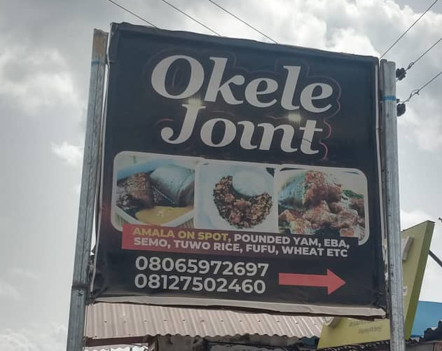 | 
(A) Okele Joint  Amala on spot, Pounded Yam, Eba, Semo, Tuwo, Rice, Fufu, Wheat, etc. | (B) Edinwo Supermarket  Quality product at affordable price
Figure 2: Yoruba multilingualism in commercial signages.

These signs exemplify a trend that highlights the blending of linguistic and cultural identities in Ilorin's public spaces. In Image A, the term "okele" is used to refer to various starchy foods in Yoruba cuisine, which are close to dumplings and are typically eaten with soups. Examples of the types of "okele," such as amala, pounded yam, eba, semo, tuwo, rice, fufu, and wheat, offered at the restaurant are included in the image. The use of the term "okele" in this context reflects the integration of local food traditions into the commercial landscape. Additionally, the use of the term "joint" to describe the restaurant is an example of the incorporation of informal Nigerian English parlance into the signage. In Image B, the term "edinwo," which means "discounted" in the local language, is used to identify the supermarket. This usage of a local linguistic element in the commercial signage demonstrates the blending of multiple languages in Ilorin's public spaces.
Yoruba Names for Personal Business: It is common to see sign boards of business outfits that constitute multilingualism by the inclusion of only Yoruba proper name. Figure 3 below, for example, demonstrates a multilingual advert for a business center, which is presented in Yoruba and English:
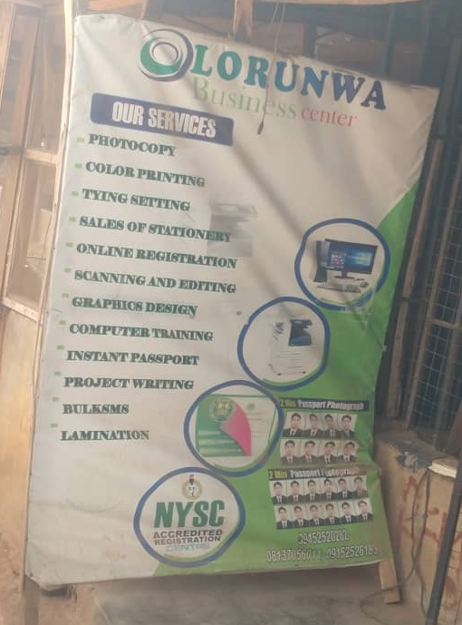
Figure 3: Banner advert of Olorunwa Business.

The above sign presents information about the services provided by Olorunwa Business Center. The name "Olorunwa" is a common Yoruba proper name that means "God exists." This phrase carries significant cultural and religious connotations, reflecting the Yoruba people's reliance on God and their invocation of divine intervention in their daily dealings. This name choice highlights the importance of faith in the Yoruba culture and underscores the business's connection to its local roots. More examples of using Yoruba names to identify personal businesses are presented in grouped images in Figure 4, below:
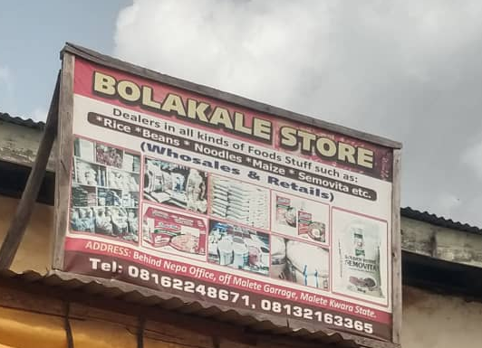 | 
(A) Bolakale Store  Dealer in all kinds of foodstuff  Such as rice, beans, noodles, semovita, etc.  Wholesales and retails | (B) Olawuyi  Electrical Contractor  Electrical materials are sold here &  AC & DSTV Installer
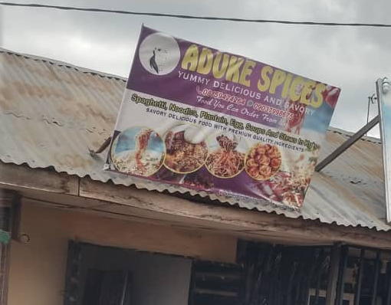 | 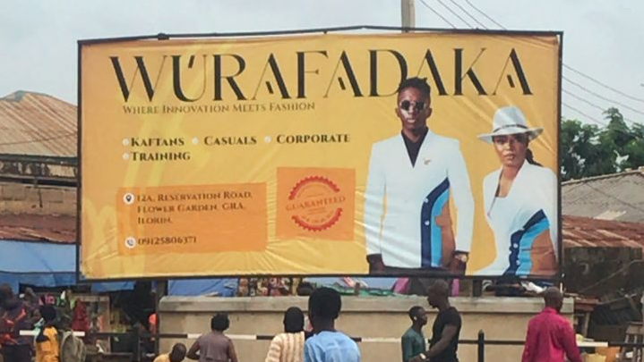
(C) Aduke Spices  Yummy Delicious and Savory  Spaghetti, Noodles, Plantain, egg, Soups and Stew  Savory delicious food with premium quality ingredients | (D) Wurafadaka  Where innovation meets fashion  Kaftan, Casuals, Corporate, Training  Bespoke outfit within two days Guaranteed
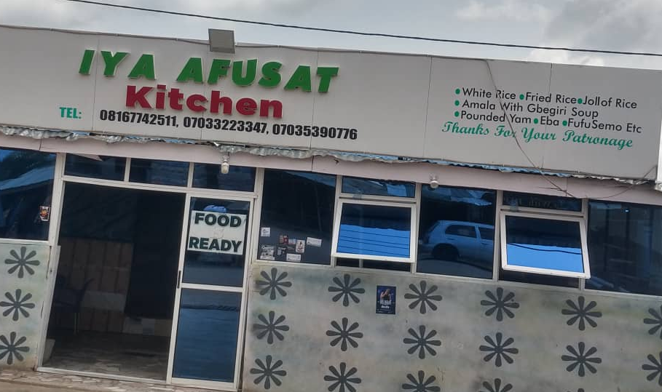
(D) Iya Afusat Kitchen
White Rice, Fried Rice, Jollof Rice
Amala with Gbegiri Soup,
Pounded Yam, Eba, Fufu, Semo, etc.
Figure 4: Examples of Yoruba names used to identify personal businesses.

The inclusion of Yoruba names in English-dominant signs, such as the above, represents a common trend in business naming practice encountered in this study. This trend reflects the blending of linguistic and cultural identities in Ilorin's public spaces, where local businesses seek to portray their Yoruba identities while still operating within the broader English-dominant economic context.

2. Yorubanized Arabic Words: Contact with Islam and Arabic culture has led to the adoption of many Arabic loanwords into the Yoruba language, including in the Ilorin dialect, enriching the Yoruba multilingualism in Ilorin public spaces. The Ilorin multilingual environment includes the presence of Yorubanized Arabic words, which, according to Jaiyeola & Daramola (2023) have been domesticated and incorporated into the local dialect. We see examples in the data below.

 | 
(A) Alubarika  Block Industry | (B) Alfa Eleja Frozen Foods
Figure 5: Yorubanized Arabic words used to name personal businesses.

Image A above presents the name of a building block manufacturing company, "Alubarka." This is a domesticated Arabic word meaning "blessing" in English. It is commonly used in Yoruba culture and language, particularly in religious and spiritual contexts. The word has been incorporated into the Yoruba lexicon and is often used in communication. In this context, it describes the business name as a blessing. Similarly, Image B describes the owner of a frozen food business as "Alfa Eleja." The term "Alfa" in Yoruba also has its roots in Arabic, commonly understood to derive from the word "Al-faqih," which means one who is versed in fiqh or Islamic jurisprudence. This term has been adapted into Yoruba and is widely used among the Yoruba people to refer to a Muslim scholar or occasionally any practicing Muslim. The accompanying word "eleja" means a "fish seller." So "Alfa Eleja," which translates to "the fish seller Alfa," describes the identity of the business owner.
In sum, the linguistic landscape in Ilorin is complex, incorporating various languages to serve different purposes. While official signs are primarily in English and Yoruba, there's an increasing trend towards multilingual displays, with Arabic included alongside Yoruba and English in many instances. Businesses frequently use a combination of English and Yoruba on their signboards, catering to a wider audience. The dominance of Yoruba and English, with the inclusion of Arabic, Hausa, and Nupe, in some contexts, demonstrates how language use on public displays can mirror the social, cultural, and religious dynamics of a multilingual city. This linguistic landscape not only reflects Ilorin's historical and cultural context as a meeting point for various ethnic groups. The multilingual signs also provide a unique opportunity for language learners to engage with the target language and cultural experience.

Linguistic Landscape: Ilorin Like the South-West Nigeria
The linguistic landscape analysis of Ilorin, as presented in this paper, uncovers striking parallels with the sociolinguistic patterns observed in predominantly Yoruba-speaking cities of South-West Nigeria. Sanuth's (2019) investigation into the linguistic landscape of Yoruba-speaking cities that host study abroad learners reveals the multilingual repertoires of Yoruba speakers in public settings. He characterizes these sites as "contexts of linguistic bricolage," where Yoruba is just one of many linguistic resources at play (p. 83). Furthermore, Mori and Sanuth (2018) highlight the complex linguistic environment that students encounter during study programs in a South-West Nigerian context. They describe how students navigate between the "monolingual utopia" they aim for and the "translingual realities" they encounter in Nigeria.
Our investigation into Ilorin's linguistic landscape corroborates this characterization, demonstrating that the city, like its South-West counterparts, presents a complex tapestry of languages in its public spaces. The data from Ilorin's signage offers a window into the city's linguistic diversity and the relative prominence of different languages in the public sphere. This analysis not only provides insights into the local linguistic ecology but also situates Ilorin within the broader sociolinguistic context of Yoruba-speaking communities in Nigeria.

Conclusion
Our analysis of Ilorin's linguistic landscape reveals a complex and dynamic multilingual environment that closely mirrors the sociolinguistic patterns observed in predominantly Yoruba-speaking cities of South-West Nigeria. As the capital of Kwara State in Nigeria, Ilorin is a melting pot of various ethnic groups, including Yoruba, Hausa, Fulani, and Nupe, among others. This diversity is mirrored in the city's linguistic landscape, where public and commercial signs display a variety of languages. Yoruba is the predominant language, visible on many public signs, street names, and commercial shop signs. However, due to the city's historical and cultural significance as a center of Islamic learning, Arabic also features prominently, especially in religious contexts such as mosques, Islamic schools, and markets. Hausa, another major language in Nigeria, is also commonly seen, reflecting the significant Hausa-speaking population in the city. English, being the official language of Nigeria, is widely used in governmental and institutional signage, as well as in educational settings. It serves as a lingua franca that bridges communication among the diverse linguistic groups in Ilorin.
The data from Ilorin's signage demonstrates a diverse linguistic mosaic in public spaces, where English takes center stage in both standalone and mixed-language displays. However, the significant presence of Yoruba, particularly in combination with English, creates an environment where the target language is readily accessible to learners. The inclusion of other languages such as Arabic, Hausa, and Nupe further reflects the city's historical and cultural context as a meeting point for various ethnic groups.

This linguistic diversity in Ilorin aligns with Sanuth's (2019) characterization of Yoruba-speaking cities that host study abroad learners as "contexts of linguistic bricolage" (p. 83). Just as in South-West Nigerian cities, Yoruba in Ilorin is one of many linguistic resources at play in public settings. These parallel challenges the expectations that Yoruba language study abroad programs should be exclusively located in areas where Yoruba is the primary language. Our analyses challenge traditional assumptions about ideal locations for Yoruba language study abroad programs and open new possibilities for enriching these educational experiences.
The multilingual nature of Ilorin's linguistic landscape will offer several advantages for Yoruba language learners, including authentic language exposure, cultural awareness, pragmatic language skills, and critical language awareness. These findings have significant implications for the design and implementation of Yoruba language study abroad programs. Rather than seeking out monolingual "utopias," program developers should embrace the multilingual realities of contemporary Nigeria.
By incorporating cities like Ilorin into Yoruba study abroad programs, students can gain a more nuanced and realistic understanding of the language's use in diverse contexts. This exposure can better prepare them for the complex linguistic realities they may encounter in their future interactions with Yoruba speakers. Moreover, the linguistic landscape of Ilorin can serve as a valuable pedagogical tool, promoting autonomous learning and encouraging students to explore and analyze language use in their surroundings independently. However, it's important to note that embracing multilingual study abroad environments also presents challenges. Program developers and instructors must carefully consider how to balance exposure to multiple languages while maintaining a focus on Yoruba acquisition.
In conclusion, this study demonstrates that Ilorin's linguistic landscape offers a rich and authentic environment for Yoruba language study abroad, challenging traditional notions of ideal immersion settings. By embracing the multilingual realities of contemporary Nigeria, study abroad programs can provide students with a more comprehensive and nuanced understanding of Yoruba language and culture, better preparing them for the complex linguistic environments they may encounter in their future engagements with Yoruba-speaking communities.

References:
Adegbija, E. (2004). Language policy and planning in Nigeria. Current Issues in Language Planning, 5(3), 181-246.
Aito, E. (2005). Language policy and language planning in Nigeria. In S. Aztech (Ed.), Language policy and planning in Africa (pp. 187-216). Multilingual Matters.
Backhaus, P. (2007). Linguistic landscapes: A comparative study of urban multilingualism in Tokyo. Multilingual Matters.
Bamgbose, A. (1994). Pride and prejudice in multilingualism and development. In R. Fardon & G. Furniss (Eds.), African languages, development and the state (pp. 33-43). Routledge.
Ben-Rafael, E., Shohamy, E., Amara, M. H., & Trumper-Hecht, N. (2006). Linguistic landscape as symbolic construction of the public space: The case of Israel. International Journal of Multilingualism, 3(1), 7-30.
Blackwood, R. J., Llewellyn, C., & Peters, H. (2016). Linguistic landscapes and the semiotics of place. In R. J. Blackwood & E. G. T. Macdonald (Eds.), Linguistic landscapes: A comparative analysis of urban multilingualism (pp. 1-14). Bloomsbury.
Blackwood, R., Lanza, E., & Woldemariam, H. (Eds.). (2016). Negotiating and contesting identities in linguistic landscapes. Bloomsbury Publishing.
Blommaert, J. (2010). The sociolinguistics of globalization. Cambridge University Press.
Blommaert, J. (2013). Ethnography, superdiversity and linguistic landscapes: Chronicles of complexity. Multilingual Margins, 1(1), 1-14.
Brock-Utne, B. (2003). Language, culture, and education. In J. W. Tollefson & A. B. M. Tsui (Eds.), Medium of instruction policies: Which agenda? Whose agenda? (pp. 15-34). Routledge.
Canagarajah, S. (2013). Translingual practice: Global Englishes and cosmopolitan relations. Routledge.
Cenoz, J., & Gorter, D. (2006). Linguistic landscape and minority languages. International Journal of Multilingualism, 3(1), 67-80.
Cenoz, J., & Gorter, D. (2008). The linguistic landscape as an additional source of input in second language acquisition. IRAL - International Review of Applied Linguistics in Language Teaching, 46(3), 267-287. https://doi.org/10.1515/iral.2008.012
Cocq, C., Granstedt, L., Lindgren, E., & Lindgren, U. (2020). Developing methods for the study of linguistic landscapes in sparsely populated areas. GERUM Geografisk Arbetsrapport.
Coleman, J. A. (2006). English-medium teaching in European higher education. Language Teaching, 39(1), 1-14.
DeKeyser, R. M. (2007). Practice in a second language: Perspectives from applied linguistics and cognitive psychology. Cambridge University Press.
Gillespie, K. (2002). The effects of study abroad on the development of fluency. In D. E. Alatis & C. A. Straehle (Eds.), Georgetown University Round Table on Languages and Linguistics 2000: Linguistics, language acquisition, and language teaching (pp. 134-144). Georgetown University Press.
Gorter, D. (2006). Introduction: The study of the linguistic landscape as a new approach to multilingualism. International Journal of Multilingualism, 3(1), 1-6.
Gorter, D., Marten, H. F., & Van Mensel, L. (2012). Minority languages in the linguistic landscape. Palgrave Macmillan.
Higuchi, N., et al. (2023). Language learning in study abroad: The multilingual turn. Routledge.
Ivkovic, D., & Lotherington, H. (2009). Multilingualism in cyberspace: A linguistic landscape of digital signage. International Journal of Multilingualism, 6(3), 241-256.
Jaworski, A., & Thurlow, C. (2010). Introducing semiotic landscapes. In A. Jaworski & C. Thurlow (Eds.), Semiotic landscapes: Language, image, space (pp. 1-40). Continuum.
Kinginger, C. (2009). Language learning and study abroad: A critical reading of research. Palgrave Macmillan.
Kinginger, C. (2013). Language and culture in study abroad: Contested meanings and uneven power relations. Modern Language Journal, 97(4), 857-873.
Lamidi, M. T. (2013). The Phonology of Ilorin Yoruba Loanwords. Ihafa: A Journal of African Studies, 6(1), 1-20.
Lamidi, M. T., & Aboh, S. C. (2011). Yoruba-English code-mixing in contemporary Yoruba novels. Journal of West African Languages, 38(2), 23-35.
Landry, R., & Bourhis, R. Y. (1997). Linguistic landscape and ethnolinguistic vitality: An empirical study. Journal of Language and Social Psychology, 16(1), 23-49. https://doi.org/10.1177/0261927X970161002
Malinowski, D. (2015). Opening spaces of learning in the linguistic landscape. Linguistic Landscape, 1(1-2), 95-113. https://doi.org/10.1075/ll.1.1-2.06mal
Mori, J., & Sanuth, K. K. (2018). Navigating between a monolingual utopia and translingual realities: Experiences of American learners of Yoruba as an additional language. International Journal of Multilingualism, 15(4), 397-413.
Oloso, Y. O. (2018). Language against Ethnicity: The Conflicting Linguistic and Ethnic Identities of the Fulani People of Ilorin. International Journal of Language and Linguistics, 5(1), 46-50.
Pennycook, A., & Otsuji, E. (2015). Metrolingualism: Language in the city. Routledge.
Pot, A., et al. (2022). The multilingual reality of study abroad: A critical review. Journal of Language and Intercultural Communication, 25(1), 1-15.
Reh, M. (2004). Multilingual writing: A reader-oriented typology—with examples from Lira Municipality (Uganda). International Journal of the Sociology of Language, 2004(170), 1-41.
Rowland, L. (2013). The pedagogical benefits of a linguistic landscape project in Japan. International Journal of Bilingual Education and Bilingualism, 16(4), 494-505. https://doi.org/10.1080/13670050.2012.708319
Sayer, P. (2010). Using the linguistic landscape as a pedagogical resource. ELT Journal, 64(2), 143-
Shohamy, E., & Gorter, D. (Eds.). (2009). Linguistic landscape: Expanding the scenery. Routledge.
Shohamy, E., Ben-Rafael, E., & Barni, M. (2010). Linguistic landscape in the city. Multilingual Matters.

