SHAO AWONGA YEARLY MASS WEDDING FESTIVAL, KWARA STATE
AUTHOURS:
MORENIKE FOLABALOGUN
morenike.folabalogun@kwasu.edu.ng
moreneeb@gmail.com
MOBILE NUMBER- 08034502388
KWARA STATE UNIVERSITY, MALETE
COLLEGE OF HUMANITIES, MANAGEMENT AND SOCIAL SCIENCES
SCHOOL OF VISUAL AND PERFORMING ARTS
DEPARTMENT CREATIVE ARTS AND TOURISM (ART HISTORY UNIT)

SHERIFF.O. OJETUNDE
Sheriff.ojetunde@kwasu.edu.ng
cchiefceramo@gmail.com
MOBILE NUMBER-08025649338
KWARA STATE UNIVERSITY, MALETE
COLLEGE OF HUMANITIES, MANAGEMENT AND SOCIAL SCIENCES
SCHOOL OF VISUAL AND PERFORMING ARTS
DEPARTMENT OF CREATIVE ARTS AND TOURISM

Abstract
This write up sets to throw more light on the yearly performance of Shao people. The write up focuses on the 2019 mass wedding ceremony, highlighting the importance of the key cultural players like the Oba of Shao, the Iboo of Shao, the Ohoro of Shao and finally the brides. Methodology used for this write up includes non-participatory observations, oral history, and oral interviews with prominent cultural personalities of the players in the festival. Culture is dynamic and it’s the sum total of man and when any aspect of culture is changed, the culture assumes a new form. The foundation of traditional religion and worship forms the bedrock of all traditional worship and deities; Shao Awonga community is not an exception. The most important and perhaps the only deity celebrated by all in Shao Awonga is the Awon goddess. This write up focuses on the 2019 mass wedding festival performance in Shao.
Keywords: Awon, Brides, Ekun Iyawo, Festival, Mass.
Introduction
A wedding is a ceremony where two people or a couple are united in marriage. Wedding traditions and customs vary greatly between cultures and ethnic groups. In the 21st century Nigeria across ethnic groups, traditionally the Shao Awonga mass wedding is still the most prominent and popular done in Shao, Kwara State and in Nigeria generally. Shao Awonga town is made of twenty traditional compounds. Fifteen elites were selected to form the Shao Awonga Forum(SAF) in order to revive and see to it that the objectives of the festival is sustained, and Elder Abel Awonshola Adewole the Chairman, Local Organizing Committee for culture and tourism has been a positive crusader of this course. Shao Awonga community is situated in Moro Local Government Area of Kwara State in Nigeria. The Shao Awonga people are predominantly Muslims, Christians and Traditionalists in terms of religious affiliation. They speak the Yoruba language and according to historical oral tradition, they believed that they are from Ile-Ife and consider themselves Yoruba by ethnicity and descendants of the Yoruba progenitor Oduduwa.
Every year the town comes alive and witnesses’ influx of visitors within and outside Nigeria to grace the annual mass traditional wedding tagged ‘Awonga’ mass wedding festival with pomp and pageantry. The recent festival was celebrated on the 1st of November, 2019, at Shao Awonga town on the field of Seventh day .Adventist Secondary School, Shao in Moro Local Government Area of Kwara State. In an interview with Adewole on the 1st of November 2019, he explained that, Shao Awonga mass wedding is unique and it is the only mass wedding in Nigeria that is traditionally observed yearly. This study employs a historical approach to ascertain the origin, period, role and cultural background of the Shao Awonga people. Information for the study was obtained from oral interviews, non- participatory observation, analysis, and available literature on Shao Awonga mass wedding festival. The effects of Islam and Christianity on the festival are examined. The paper concludes by suggesting that culture is the sum total of man which includes language, dance, musical instruments, food, geographical location, arts and crafts, religion, beliefs, architecture, occupation, myths, norms, values and costume. When any aspect of a culture is influenced, the culture assumes a new form. Culture does not make people; people make culture (Adichie, 2014).
Historical Origin
Every year, Shao Awonga comes alive and witnesses’ influx of visitors within and outside Nigeria to grace the annual mass traditional wedding ceremony tagged ‘Awon’ mass wedding festival with pomp and pageantry. The latest festival was celebrated on the 1st of November, 2019, at Shao town on the field of Seventh day Adventist Secondary School. In an interview conducted with Ojetunde on the 1st of November 2019, he explained that, oral tradition accounts that a hunter’s son, after hunting expedition, used to go to a small stream for a drink of water. On one of such occasions he met a strange woman with only one breast, believed to be a fairy tale woman whose name was given as Awon. The mysterious woman claimed the ownership of the small stream where the hunter’s son (Omo Larele) had been drinking from and later resurfaced in the community and paid a visit to the then first Ohoro of Shao, Oba Olanibo and the community folks.
One school of thought said that Awon spent nine (9) days amongst the people, while another school of thought said eighteen (18) days. Awon (goddess) was said to have held a closed door meeting with the Ohoro and his Chiefs. Awon was seen off by the Ohoro and Omo Larele the hunter’s son and Chiefs through a path chosen by Awon. In an interview conducted with Adewole on the 1st November 2019, he explained that in the farewell address of Awon, she said they would no longer see her, but urged them that a day is set aside every year to commemorate her presence among the people by ensuring that all marriageable maidens are given out in marriage in one single day. This was how the Awon mass wedding came to be, and is still in existence till today.
Adewole (Oral Interview, 2019) states that,
The Awonga goddess cannot exceed nine to eighteen days considering the fact that she is not human like mortals on earth and cannot possibly be eating what the mortals were eating at that time. The goddess was housed in their compound and the image was carved out when she became a goddess and that is where our compound derived the name from, Ele- Alawon, meaning the compound that housed the Awon goddess.
Awon goddess pledged if this was adhered to, she would always bless the people with children and also bless the descendants of Shao and strangers also would be blessed living in the community, thus requests are brought forward most especially during the Awon mass wedding festival. According to oral history, immediately Awon was done with her speech, she fell to the ground and vanished only for water to start sprouting out from that spot, becoming a spring and later becoming a bigger river called Awon river. The origin of the festival has to do with the establishment of the community, the festival started from the beginning of the community (Ayan, 2019).
In an interview with Shangodare on the 1st of November 2019, he stated that,
“Modernity has affected the festival in diverse ways, western civilization and modern religions and education has pervaded cultural climate, the Awonga wedding festival is still taking the lead in the community, despite the fact that modern religions are pervading the cultural climate it has not been able to send the festival into extinction.
The spot where Awon fell down and disappeared and water started sprouting out is called Awon Yale (Ojetunde, Shao Awonga Mass Wedding Festival, 2019), which translates to mean Awon goddess came home. The spot is very important to Shao Awon people and is referred to as Ojubo Awon (fig.1.), meaning the worship point of the Awon goddess. Another school of thought yet said, after Awon goddess left, some few days’ later two women claiming to be her sisters came looking for her and they were told she was with them for some days but has left. The two sisters that came looking for left and became river “Osun” and “Ogun. In an interview with Ayan holds that, if the festival is stopped there will be negative consequences for the community.He further expressed that Shao has festivals of Shango, Ogun, Ifa, but the most important of all their festivals is the Awon festival, the festival is distinct and is the property of the whole community.
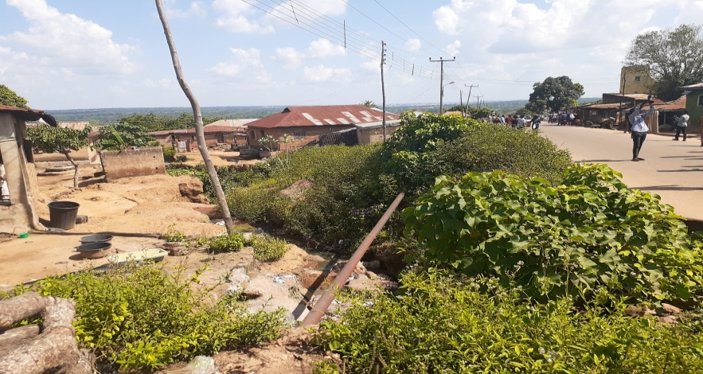
Fig: 1.Awon Yale (Awon goddess came Home)
Source: FolaBalogun and Ojetunde (2019).

Awon Shrine
The priest in charge of Awon goddess shrine is called Baba Alawon, and the present priest is Chief Olountoogun Ojetunde (Fig.3.) who is forbidden to never cross a river in his life(Oladimiji,2016).The water within the shrine speaks to him, to warn or avert calamity for the community. In an interview conducted with Okanlawo 2016, she explained that, if somebody dies in the river and the priest of the Awon shrine is consulted, a white ram and a pigeon are used. The white ram will be allowed to walk inside the river, anywhere it stops then the pigeon will fly and will perch on the ram. The priest will then know that, that is the location of the dead person the corpse will be removed and carried out of the water. Necessary rites will be done and the corpse will be buried at the river bank.
In an oral Interview conducted with Elder Abel Awonshola Adewole in 2019 as the Chairman Local Organizing Committee for culture and tourism stated that, Shao Awonga festival accounts of Oladimiji (Oral Interview, 2016) and Okanlanwo (Oral Interview, 2016) are true but that, it happened when the people of Shao Awonga were still worshipping and offering sacrifices to the Awon goddess, that now the worshipping aspect has been stopped, only the traditional aspect of the mass wedding that we can see today is still adhered to. The festival has been since the inception of the community, and it is unique and in Africa there is none like it. It is an annual event, handed down by a visitor, that can be liken to a mermaid, and appeared to the villagers as a human being. She was taken to the Head of the community because nobody could house such a person in those days except the Head of the community. He further stressed that, Ojubo was the spot where she goddess disappeared, and sacrifices were made in those days on that spot. The introduction of Christianity and Islam actually eroded some aspects of the festival, Adewole, 2019 concluded.
In an oral interview conducted with Shangodare Ayan in 2019,he stated that, himself takes care of the Shango aspect and that of all the festivals in the town, Shao Awonga mass wedding is the most prominent and important. He further stressed that western civilization has not been able to erode the festival. Shangodare believed that, if the festival is not done or abolished by the community, the generational negative effect of the positive blessings made on the community can take effect. The annual mass wedding festival focuses on the reaffirmation and pledge of the people made to Awon goddess, in order to continue to get her blessings. With the influence of Christianity and Islam, some newly married normally opt out of Alawon’s (Chief priest) blessings for that of their Pastors and Imams. The Alawon actually blesses the newly wedded the following day of the festival.
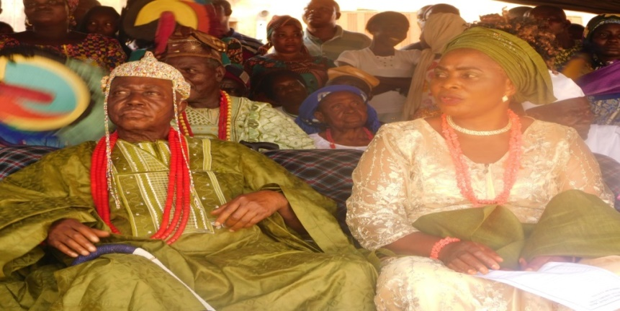
Fig:2. Oworo of ShaoAwon,Dr.Alhaji Bamidele Adegbite Oyinnola III
Source: FolaBalogun and Ojetunde, (2019).

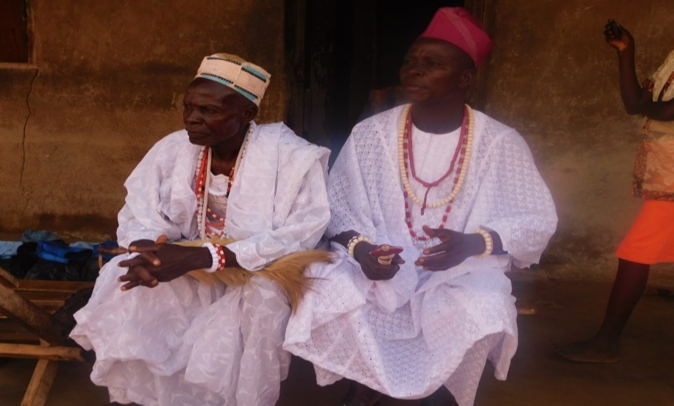
Fig: 3.Chief Olountoogun Ojetunde (left in white cap)
Awon priest also known as (Baba Alawon)
Source: FolaBalogun and Ojetunde (2019).

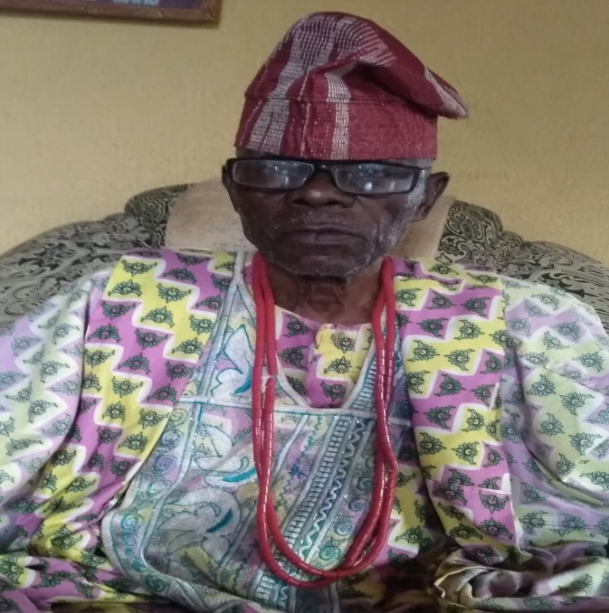
Fig: 4. Chief Daniel Omirinde, Iboo of Shao
His ancestral fore father’s bloodline met the Awon goddes
Source: FolaBalogun and Ojetunde (2019).

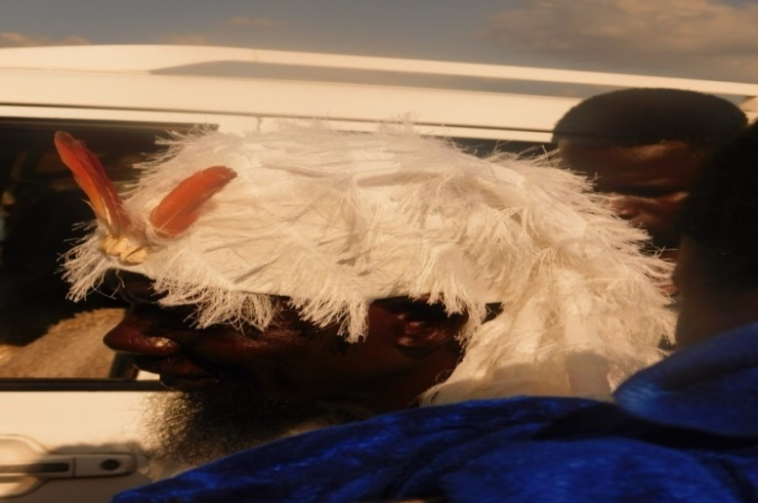
Fig: 5. Babarisa of Kwara State
Source: FolaBalogun and Ojetunde, (2019).

Mass Wedding Preambles
Every year, Shao Awonga town comes alive and witnesses’ influx of visitors within and outside Nigeria to grace the annual mass traditional wedding festival tagged ‘Awon’ mass wedding festival with pomp and pageantry. Series of meetings were held with the Oba Shao, the Iboo, (fig.4) the Ajaniki and other religious leaders in the community, to determine when and how the wedding activities will go. The messenger will go round to jingle a bell in announcement with jubilation. The parents of the brides to be will start preparing towards the great occasion. Colorful fabrics of aso-oke (Yoruba traditional fabric), kitchen utensils, statement accessories, food stuffs are purchased for the occasion. The whole community is involved in the preparation for the occasion. Awon festival is not expensive like other modern weddings. Shao Awonga Forum (SAF) was set up as a body to see to the arrangement and management of the festival.
Awonga Mass Wedding (2019)
The 2019 festival was celebrated on the 1st of November on the field of Seventh day .Adventist Secondary School, Shao, in a colorful ceremony in the presence of dignitaries, family members and well-wishers and prominent personalities. Dignitaries include: the Ohoro of Shao (fig.2) and traditional dignitaries like Obarisa of Kwara State (fig.5) and a female cult member in (fig10) and a host of others, such as Chairman of Moro Local Government, and Members of State Executive Council. Different types of entertainment groups also featured like the Acrobatic display groups, Akikunju ode ilu Ilorin (cultural display by the hunters of Ilorin), Ajobiewe musical group, Alagbe musical band (figs.11a&11b) and Kwara State Council for Arts and Culture Troupe. An important aspect of the ceremony is the Ekun Iyawo (Cry of a newly wedded wife, (p.10&12.).
The ekun iyawo is rendered one after the other in the open arena, acknowledging the Oba Shao (fig.2) and the bride’s parents for all the parental care and up bringing from birth to marriage period. The Oba of Shao will stand up to spray legal Nigerian currency on the brides as they are praising him. The parents, in-laws and husbands to-be will likewise stand up to give them money, while the crowd will applaud them. The ekun iyawo varies from one person to another, in tonal pitch, wordings and mode of praises. The ekun iyawo is like a farewell, thanksgiving and departing wordings, directed at their parents, but acknowledging the Oba, who is on seat at that very moment. All the newly wedded brides (figs.6&8) are in groups of the same outfit with an umbrella each. In the 2019 festival, there were twenty-four different worded types of ekun iyawo praises rendered by the twenty-four brides. Below (p.10-12) is an example of ekun iyawo rendition and English translation. Some of the newly married brides, after the traditional mass wedding, still go to the church and mosque for blessings.
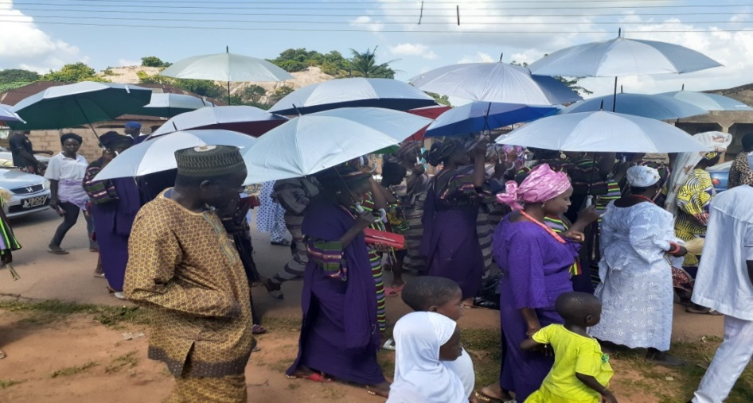
Fig: 6. Brides to be in procession to Venue.
Source: FolaBalogun &Ojetunde

The Rendition (Yoruba Language) Ekun Iyawo
Eu kike ti e kemi o e
Esi ku gige ti e gemi o a
Eku ogbon inu ti e ro mi ti o ju aso alo
Emi lo bi won fi abere gun yan ti ko gbodo dikoko
Emi lo bi won fi ogbono roka ti ko gbodo ho yaya
Odo kan odo kan ti n be larin igbe,Ara iwaju ko gbodo de be,
Ero eyin ogbodo de be, emi asake de be mo fi omi bo oju
Oju mi wa di oju oge
Idi mi wa di idi ileke, ileke merindilogun ti n be ni idi emi asake te ba ka ti o ba gbe aso ni esin ema sin idi mi, tori oun mo gbe wa n be labe aso
Kini mo se fun ila? Ti ila fi koo
Kini mo se fun ikan? Ti ikan fi wo ewu eje
Kini mo se fun baba mi? To ni ma re ile oko
Kini mo se fun iyami? To ni ma re ile oko
Egun ile iyami re ile oko
Osa ile baba mi re ile oko
Emi lo bi omo keke ile bu ni ti n gbodo bu temi dii
Mo jojo mo jo de ile oko, oko fi le mi iwaju
Mo jojo mo jo de ile ale, ale fi naira kan le mi iwaju
Eba mi ki oko pe o ku orire
Eba mi ki ku ale pe o ku ase danu
Ase danu ti nba ile ore je
Iyawo asi bere si ma sukun!! (Lateefat, 2019)
Translation
Thanks for your nurturing and pampering and thanks for your value for me. Thanks for the inner knowledge given to me that is more than tying a wrapper. I am going to where they use a niddle to pound yam that must not have lumps. I am going to where they use ogbono (a type of local Nigerian soup used in eating solids/Morsel) to make Amala, that must not over boil. There is one river; there is one river that is between the bushes, that those ahead are forbidden to go there. The people at the back are forbidden from going there, myself Asake (bride’s name) went there and use the water to wash my face and my face became that of a beautiful face. My waist became the waist of beads, sixteen beads on my waist Asake (name of Bride) if I count the beads and it is not complete, it is the cloth you should uncover not my nakedness, because what I carry is under the cloth. What have I done to Okra? That Okra has grown wild. What have I done to garden egg? That the garden egg worn a cloth of blood. What have I done to my father? That he said I should be going to my husband’s house.
What have I done to my mother? That she said I should be going to my husband’s house. The masquerade in my mother’s house is going to her husband’s house. The deity in my father’s house is going to her husband’s house. I am going to my junior in -law’s house where when am insulted I must not retaliate. I dance and dance to my husband’s house, and my husband pasted one Kobo on my fore head. I dance and dance to my concubine’s house, my concubine pasted one naira on my fore head. Help me to greet my husband that he has chosen well for himself. Help me to greet my concubine for a wasted effort of no gain, a wasted effort, which spoils the house of friendship. The bride starts sobbing seriously at this stage.
The State Government, parents, friends and well-wishers gave the newly wedded lot of gifts (fig.7). Popular Yoruba Musicians and traditional drummers (fig.9) grace the occasion with beautiful modern traditional renditions for hours to the peoples delight.
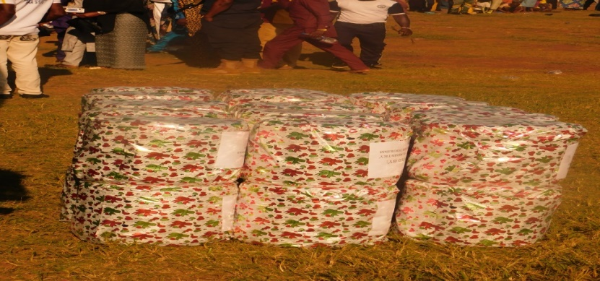
Figure: 7. Gifts for the Brides
Source: FolaBalogun & Ojetunde (2019)

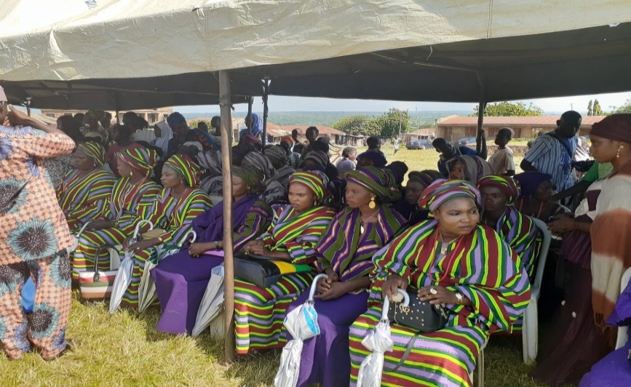
Figure:8. Brides to be in colourful group traditional Yoruba attire called Aso-oke
Source:FolaBalogun and Ojetunde(2019)
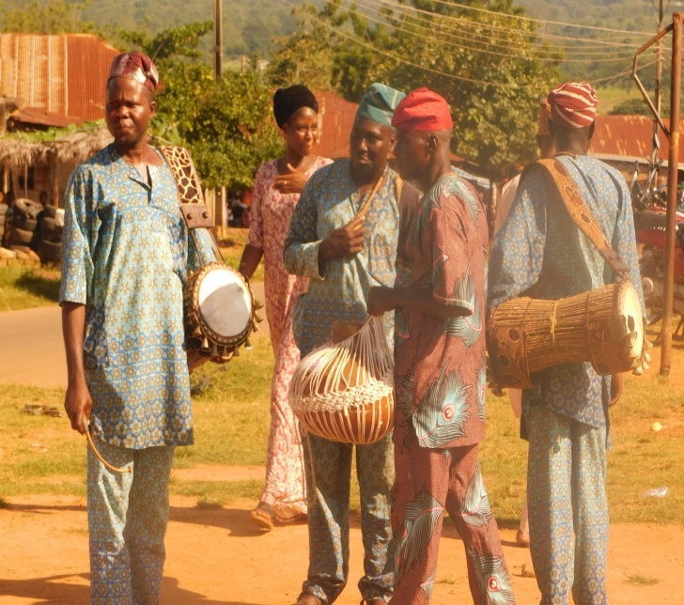
Fig: 9.Yoruba Traditional Musicians, Shao Awonga Festival, 2019
Source: FolaBalogun and Ojetunde (2019)

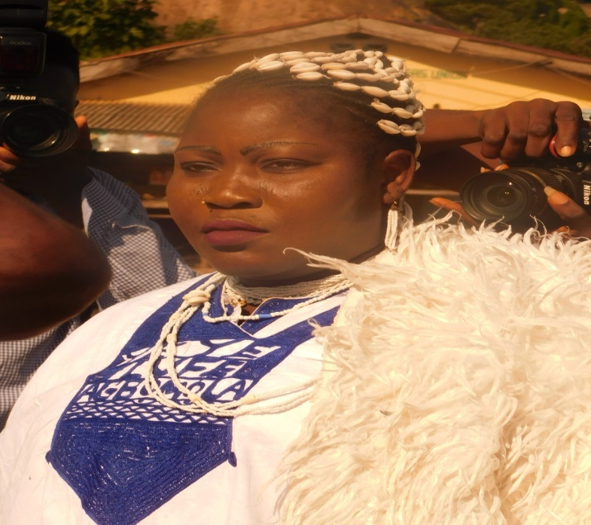
Fig: 10. A Member of the River Cult
Source: FolaBalogun and Ojetunde (2019).

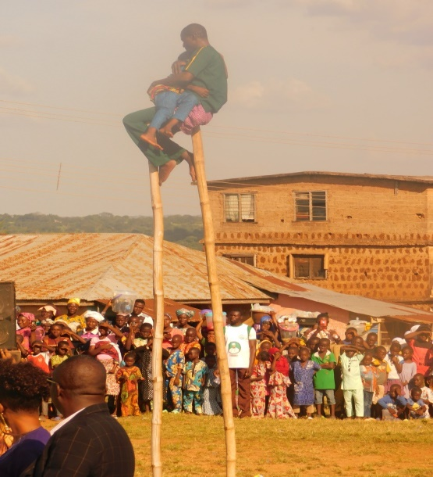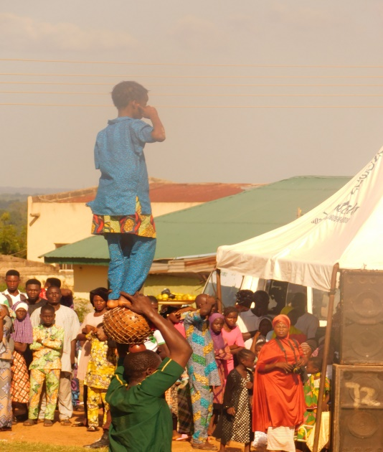
Fig:11a.Alagbe Cultural Troupe Fig:11b.Alagbe Cultural Troupe
Source: FolaBalogun and Ojetunde (2019) Source: FolaBalogun and Ojetunde (2019)

Conclusion
The implication of this write up is that, people define their culture by themselves and their taste goes a long way to define who they are. Culture, as a sum total of man which includes, Food, Music, Musical instruments, Language, Myths, Values, Norms, Religion, Costume, Dance, Physique, Arts and Crafts, Architecture and geographical location lays an important role in life, change any of these, and the culture will definitely assume a new form. Culture evolves, thus any culture that is static will die or cease to exist. Many factors like religion (Christianity and Islam), education, internet incursion, exposure to other cultures have affected the worship of the Awonga goddess and the yearly Shao Awonga mass wedding, but these factors are not strong enough to send the yearly festival into extinction. The festival is as old as the community and it has been passed down from generation to generation. The ancient historical account of Awon goddess and the pledge of their ancestors to the demand of Awon goddess is the machine that creates the mass wedding festival norms, values, beliefs and tradition of Shao Awonga and it is on that foundation that the Shao Awonga festival was established.

References
Adewole, A. A. (2019, November Friday,1st). Shao Awonga Mass Wedding Festival,2019. (M. FolaBalogun, Interviewer)
Adewole, A. A. (2019, November 1st). Shao Awonga Mass Wedding Festival,2019. (M. FolaBalogun, Interviewer)
Adichie, C. (2014). We Should All Be Feminists,pp 13 and 21.eBook ISBN:978-1-101-87293-2. Published in United States by Vintage.
( 28th October 2016). AWON MASS WEDDING Festival.
Ayan, S. (2019, November 1st). Shao Awonga Mass Wedding Festival. (M. FolaBalogun, Interviewer)
https://en.wikipedia.org>wiki>wedding. (n.d.). Retrieved November retrieved 4th, 2017
Ibitola. (2015, November). Infoguide Nigeria. Retrieved November 8th, 2016, from http://infoguidenigeria.com/awon.Retrieved 23rd October 2019.
Lateefat, S. (2019, November 1st). Ekun Iyawo. (M. FolaBalogun, Interviewer)
Ojetunde, A. (2019, November 1st). Shao Awonga Mass Wedding Festival. (M. FolaBalogun, Interviewer)
Okanlawon, M. S. (2016, November 8th). AWonga Mass Wedding Festival,Shao. (M. FolaBalogun, Interviewer)
Oladimiji, S. (2016, November 6th). Awonga Mass Wedding Festival. (M. FolaBalogun, Interviewer)
Oladimiji, S. (2017, November 1st-2nd). Awon Mass Wedding Festival. (M. FolaBalogun, Interviewer)
www.myfinancialintelligence.com>100. (n.d.). Retrieved November retrieved 4th, 2017

