Code-switching as a strategy of evasive language use on Instagram
Abstract
Code-switching, (and code-mixing or any form of juxtaposing), a phenomenon characteristic of bilingual speech, has become more notable in writing with the advent of social media. This study investigates the use of words and expressions considered unacceptable by the Community Guidelines of social media applications by focusing on the evasive use of indigenous Nigerian languages on Instagram, a social media platform. Expressions that are considered ‘undesirable’ come up more consistently in indigenous languages when compared to their English equivalents. Thus, there is more code-switching/mixing on the platform than traditionally assumed. Extant studies on code-switching have addressed the phenomenon from the learning, interactional and expressive perspectives, but the discussion on its evasive use on social media platforms has not been equally addressed. Such studies mainly focused on the positive functions of CS. This study employs a corpus method of data collection to gather texts from purposively selected accounts and uses the discourse analysis framework to identify the strategies that foster evasive language use. The findings identify the negative function of CS and writing in an indigenous language as evasive strategies employed by Nigerian Instagram users in their social media posts.
Keywords: social media, code-switching, Instagram, Nigerian languages, evasive use
- Introduction
Like many sub-Saharan countries, Nigeria is a multilingual country where people are exposed to at least two languages or varieties in their communities. Within given languages, there exist distinguishable types or levels or register. Register is an important linguistic subcategory which refers to the type of language that is appropriate for particular situations (formal or informal register). One of the major characteristics of bilingual speech is code-switching between languages, varieties or registers.
The study of the language of the (social) media represents a fast-expanding area of Applied Linguistics and Language Engineering. One of the attributes of online language is that users can write as they please on social media. In an attempt to sanitize and protect global social media users, ‘Community Guidelines’ are used by many app(lication) developers. Therefore, the computer system (automatically) scrutinizes, detects and consequently reacts in various degrees to textual, pictorial, audio, and even video posts that contravene the stipulations of the Community Guidelines, and are deemed abrasive and obnoxious. The Nigerian cyberspace is not exempt from this scrutiny. However, some Nigerian Instagram (popularly called IG) users noticeably make posts and comments on the IG Feeds and Stories components without paying heed to those guidelines. As part of the strategies developed to evade the sanctions of the IG developers, such users have devised various strategies, including blurring some parts of the offensive words, writing in an indigenous language, or code-switching/mixing. Such actions suggest that they are aware of the ‘negativity’ of their posts and comments, but post them all the same. This study focuses on how code-switching is used as a strategy to evade the sanctions.
Instagram is a photo and video sharing social networking service owned by the American company Meta Platforms. Some features and tools are identified with the Instagram app. ‘Feeds’ is a main Instagram profile page that is designed for sharing and connecting people and things that they care about on the app. ‘Explore’is a tab inside the app that displays popular photos and promotes public ‘stories’ content from nearby places, particularly from accounts that a user is not following. ‘Reels’ enables users to record short videos which are set to pre-existing sound clips from other posts. IG ‘stories’ is a feature that allows users to take photos, add effects and layers, and add them to their stories. The uploaded images on ‘stories’ lasts for twenty-four hours, after which they are automatically deleted. Before expiration, users and followers can ‘like’ and ‘comment’ on stories using specific button icons. Instagram direct, advertising, hashtags, photographic filters, video, TV, etc., are also some of the tools and features on the app.
Previous studies on code-switching on social media have focused on language identification, point of switch (POS) tagging, and sociopragmatic competence. However, little attention has been paid to the study of code-switching on social media from the perspective of the use of profanity and elusiveness. This study aims to investigate the linguistic strategies employed by Nigerian users of Instagram in posts that are intended to evade the Community Guidelines of the app by using indigenous Nigerian languages. The study aims to document and project the identified strategies. It adopts Gardner-Chloros’ (2009) view that even though sociolinguistic approaches are sometimes considered as positing too simplistic and positivistic correlations between language and society, such approaches retain some considerable explanatory power which points towards understanding the significance of code-switching (CS) in social life. Here, CS is considered in relation to profanity with a discussion on cyberbullying that is rooted in the online use of indigenous Nigerian languages.
In an attempt to combat cyberbullying and other forms of inappropriateness in written texts, IG App developers, through automation and reporting as enshrined in their Community Guidelines, penalize offensive texts by shadow-banning, banning, hiding, downranking, flagging, suspending, or deleting posts, comments, or accounts. Despite this, however, the use of indigenous languages to violate and evade punishment has thrived unabated among Nigerian IG users, and is gradually becoming a norm.
- Review of Related Studies
Code-switching is the practice of alternating between two or more languages or language varieties within a conversation, either spoken or written. Even though there has been some identifiable differences in the literature between the terms code-switching and code-mixing, however in this study no distinction is made between the two. Hence, CS is used in this study as a cover term for any form of juxtaposing of languages of discourse. According to Meisel (2006), code-switching and language mixing are natural phenomena of communication among bilinguals. CS requires a certain level of proficiency in both languages in order to choose words, articulate, and string them together in an acceptable and grammatical way (Isaiah, 2022). While CS could be discussed under three main perspectives which are the psycholinguistic, the grammatical or stuctural, and the sociolinguistic perspectives (Akinremi, 2016), this study is based on an aspect of the sociolinguistic perspective. According to Gardner-Chloros (2009, p. 97), it is important to consider CS from a sociolinguistic perspective where language behaviour and use are related to speakers’ (social) identity and characteristics or to aspects of their social life in the broad sense. It is a construct derived from the behaviour of bilinguals.
A number of studies have been carried out on the code-switching of English and indigenous Nigerian languages (Adebola, 2011; Akinremi, 2016; Ayeomoni, 2006; Isaiah, 2022; Jegede, 2012; Lamidi, 2017; Taiwo & Taiwo, 2009). These studies have focused on CS in the oral medium (speech or music). However, the advent of social media has led to a surge in more scholarly works on CS in written texts. Such researches have submitted that bilinguals (particularly youths) are highly positive in their participatory attitude toward the use of CS on social media platforms (Al-Qaysi & Al-Emran, 2017; Gonulal, 2019; Merzougui, 2018). The list of positive attitudes ranges from foreign language learning, language development, and cultural identity and affiliation. Studies by Al-Qaysi and Al-Emran (2017), Johannson (2013), and Bermudez, Prasad, Alsadoon, and Hourany (2016) focused on the use of the social media by students and its significant role in the educational context. Al-Qaysi and Al-Emran’s (2017) study on the attitudes of higher education students and educators towards the use of CS in social media using interviews, reports that participants claimed that CS helped to convey new words easily while switching between English and Arabic. CS also allowed them to express ideas that they could not express in Arabic. However, it is also true that what cannot be expressed in one language could be profane, such that code-switching becomes a way to avoid extensive scrutiny. Al-Qaysi and Al-Emran’s study did not examine this possibility. Another study by Samhan (2017) identifies age, gender, and education as factors that affect the use of CS and code mixing on Twitter. Overall, the results of these studies revealed positive attitudes to the use of CS on social media.
McClure (1997) is an example of studies that analyse written CS between English and national languages in countries such as Spain, Mexico, and Bulgaria. Findings from the study show that even though English is widely known in Mexico, the resentment against it makes CS functional. Similarly, an avoidance of CS between any two indigenous languages by Nigerian users of social media, notably IG, has been described in the literature. For instance, Goglia (2004) notes the avoidance of CS between Igbo and Yorùbá, which the author attributes to various factors. The author identified the concept of the negative use of CS on social media among Nigerian users, which is of particular bearing to this study. This study therefore interprets and categorises the instances of CS and other words and expressions used on Instgram.
Some studies indicate that social networking platforms, such as IG, serve as a mobile-assisted language learning tool (e.g. Gonulal, 2019). However, there is also a downside to language use on social media. For instance, cyberbullying has been identified as one of these vices (Balogun, Awodele, Bello, Oyekunle & Balogun, 2017). Studies by Anyanwu (2023), Anyanwu and Udoh (2021), and Ogunwale, Ojo, and Akinsola (2019) investigate the issue of cyberbullying in Nigeria with focus on the use of the English language for its perpetration. However, the use of indigenous languages was not the focus of these studies, nor did they consider demographics other than Nigerian students.
Extant studies on social media language in Nigeria focus on Facebook, WhatsApp and Twitter platforms, with less focus on CS or its evasive intentions (Agwuocha, 2019; Josiah & Udofia, 2020; Sharehu, 2022). For instance, Agwuocha (2019) investigates the inappropriate use of language in the social media vis-a-vis discourse on national integration. The study notes that the discussion of prevalent issues such as crime, violence, conflict, elections, and insurgency are done online. It also claims that such discourses are laced with inappropriate use of language based on the perspective of lack of communicative competence amongst users. However, the study is based on conversations on Facebook and does not consider the use of CS by these Nigerian users. In the present study, the focus is on Instagram, a popular platform among social media users in Nigeria. The perpetration of cyberbullying and related tendencies in the online community and how CS involving Nigerian languages is employed to achieve this is the gap addressed in this study.
Studies on code switching on social media have shown that CS performs various functions of communication strategy. These functions include linguistic avoidance, creation of humour, and language richness (Mukenge, 2012). For example, Septiani, Petrus, and Yunus (2016) identify eight motivations for code switching on social media. Such purposes include: to have privacy; to convey intimacy; to avoid misunderstanding; to aid emphasis; ease of speaking in own language; to fill stopgap; lack of English equivalents, and; obvious difference between L1/L2. In another study, Ting and Yeo (2020) examined the functions of CS in students’ Facebook wallposts. They concluded that personalization, interjection, message qualification, addressee specification and quotation are the functions of CS in digital space, albeit these functions do not have equal amount of usage or representations. However, these studies do not show how users manipulate linguistic choices to evade social media sanctions. Therefore, this function of CS on social media platform is further investigated in this study.
- Theoretical Framework
The discussion in this study is guided by the principles of the conversational perspective on CS, which is rooted in Conversational Analysis, an approach that studies social interaction and language. According to Gumperz (1982), conversational CS is multifunctional and serves global social/metaphorical functions and local discourse management functions. The author opines that CS is “an element in a socially agreed matrix of contextualization cues and conventions used by speakers to alert addressees, in the course of ongoing interaction, to the social and situational context of the conversation” (Gumperz, 1982, p. 132). Conversational CS assumes that through the use of code-switching, speakers are able to convey their momentary attitudes, communicative intents, and emotions to other participants in a conversation.
This study looks at ordinary everyday written discourse/text among Nigerians on IG and aims to explain how users code-switch in their interactions. This study investigates the conversations under comments and posts in order to identify the motivations behind switches. Analyses are carried out on patterns in the writing, such as the use of particular words and phrases, including to convey, manage, or buttress conversation in a suitable way.
In addition, some features of the Computer-Mediated Discourse (CMD) approach, particularly those expounded by Herring (2001, 2004, & 2007) were used for analyses. According to Herring (2001), CMD is the communication produced when human beings interact with one another by transmitting messages via networked computers. It is a sub-theory of the computer-mediated communication (CMC) which, simply put, explains how people use computers and networks to communicate with one another. The CMD approach assumes that text-based human-human interaction via computers and networked devices provides an abundance of data on human behaviour and language use (Herring, 2007). CMD is less formal and does not require the same level of formatting and editing as typed ‘writing’. It also embodies a high level of anonymity, which creates an impression of direct and ‘private’ exchanges (King, 1996). These potentials, amongst others, are relevant to this study on the strategies employed to mask ‘undesirable’ words on Instagram.
- Research Methodology
The study employs a corpus method of data collection, which involves the collection of texts in their natural form, such that the data comprise naturally occurring texts. This is essential for this study to preclude presumable assumptions and generalizations about the personalities of the Instagram account owners, their followers, and commenters. The data samples for this study were obtained from IG and analysed using the CMD approach. The classification of features of CMD based modality, number of discourse, text/discourse type, and genre/register, allows the study to focus on important properties of the data under consideration. Specifically, it allows analysis of certain language use phenomena, such as CS that occur regularly on IG.
The study data are restricted to written texts (and emojis, emoticons, etc., for reactions) on IG posts and comments. These were obtained from Feeds and Stories (simply referred to as posts henceforth) of five purposively selected accounts; hence comments from Explore and Reels were excluded mainly because data from those may be considered random. Descriptive statistics for the demographic data are the following five criteria, which were satisfied by all the accounts: (1) they were public blog pages whose account names and descriptions did not depict tribal, religious, and political affiliations; (2) they had the IG verification logo; (3) they had active followers; (4) the followers were a minimum of 350,000; (5) posts and comments depicted that majority of the commenters are Nigerians.
The data were subjected to a variationist code-switching approach to demonstrate the dynamics of the data and show the results of a qualitative analysis that can be replicated. This variationist approach which is permissible in computer-mediated environments does not make participants information such age, gender, social class, etc. important in the research. Other than the account names, which are not considered reliable, participants were ‘anonymous.’ Information about nationality is however inferable mainly from the comments and sometimes from their language use. Overall, the present study used data collected in natural conversational settings online and no participant was interviewed. The findings are therefore objective interpretations based on the basic meanings of used phrases and clauses.
The data included posts between January and December, 2022. Each of the accounts used for data collection had an average of five daily posts. All relevant posts were screen-shot with an iPhone and backed up to iCloud for documentation and archiving, accessible retrieval, and future digitalization. The data initially obtained consisted about 3,000 items; however, many were discarded for reasons such as simplicity/complexity and generalization. The approximate total number of code-switched utterances in all the posts used in the analysis is 1,000. The data indicate that English, Yoruba, Igbo and Pidgin are the main languages used in the code-switches/mixes. Other languages such as Ibibio are also used.
- Data Analysis and Discussion
A considerable number of posts and comments observed in the study data manifest code-switching. In the presentation of data below, English expressions are rendered in normal typeface, while expressions in indigenous languages are in bold typeface. This is done to make the identification of codes more obvious. As much as possible, the original writing (spellings) of the posts and commenters were not altered. Names were however rendered as initials to protect people’s identity and to ensure anonymity.
To analyse the language use on IG in the Nigerian cyberspace, excerpts and images of captions and comments are presented. For some of the comments written in indigenous languages, sometimes ‘See translation’ is seen beneath them, as a way to automate the translation of the indigenous languages into English. Noticeable patterns of CS and how they were motivated or triggered on Instagram are examined below.
A single word is enough to get a post hidden (as in Figures 1 and 2), taken down, or to attract any other sanctions prescribed in the Community Guidelines of the App developers. Words such as ‘ass’, ‘stupid’, ‘kill’, etc., are offensive enough for such reasons. For Figures 1 and 2, the hidden words were opened by the researcher and put side by side with the original words for illustrative purposes. The words that got the comments hidden are ‘ass’ (Figure 1) and ‘stupid’ (Figure 2). Figure 2 further shows that such words are indeed considered offensive because two commenters ‘protested’ its usage by the first user. However, their replies were also hidden because they included the same word, ‘stupid’.
The language used on the five popular accounts that this study assumed to be of Nigerian origin, and which had no specified political and tribal affiliations, has demonstrated some of the strategies adopted by IG language use violators to conceal their offensive writing practices. It is observed that when written in English, words such as smashed, molesting, hit, mad, crack, fighting, fuck, bullying, flogged, and suicidal, were stylishly written either with covered letters or asterisks; hence, ‘bullying’ becomes ‘bullying’ and ‘fuck’ becomes ‘fxck/f^{x}ck’. These styles are enough to make it impossible for the computer to read in order to avoid penalties, while keeping the expressions explicit to the human readers. However, this strategy is not often used for words written in indigenous languages. They are often completely spelt out. Some of such expressions written (often without diacritics and tone marks) in indigenous languages and posted by relevant accounts are cited in the following excerpts and figures.
On the bottom left of Figure 1, there is an initial text that reads ‘View Hidden Comments’. Readers would have to click on it in order to read what is hidden. The bottom right of the screenshot shows the hidden expression as ‘See ass.’ The word ‘ass’ got the comment hidden. Same process is applicable to Figure 2. The sanctioned words are written in English.

Figure 1. Hidden comment ‘ass’
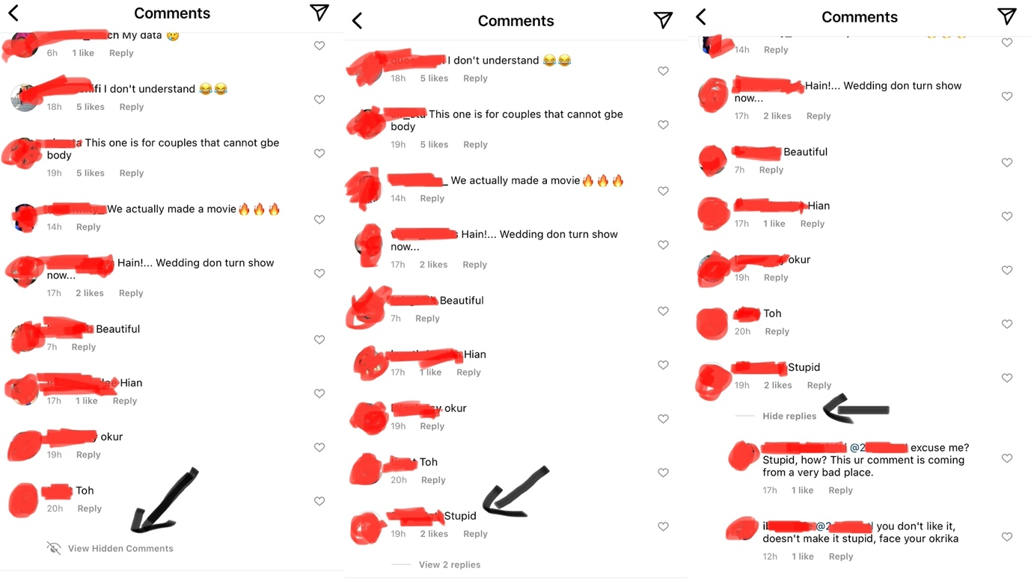
Figure 2. Hidden comment ‘stupid’ and reactions that showed users thought of it as bullying
The profane use of code-switching is also evident in excerpt 1. Here, a post about a social subject (infidelity) concerning a popular Nigerian actor was made and many of the comments were not in support of the initial post, which supported the actor’s action. To show disagreement, majority of the total of 124 comments on the post used strong words to state their opinions. Many code-switched to drive home their points. With this came a lot of vulgar words in indigenous languages and none in the English language. The translations to words written in the indigenous languages are given in brackets. (The last comment, H, is also an example of how comments in Igbo are often written without switching to English or other indigenous languages.)
Excerpt 1 CS used for profanity
A: Werey supporting werey (mad person)
B: Werey go always recognize werey (mad person)
C: ‘Going through challenges that his wandering gbola (penis) could have avoided 🤣
This R is an oniranu!!’ (nonentity)
D: Ozuor (stupid/foolish)
E: Ana akogheri (you are saying rubbish). Mkpi supporting mkpi (he-goat)
F: @E 😂😂😂
G: oponu (idiot) brother agbaya (big fool)
H: taaaaaas gbafuo. (Get out/lost). Odogwu n’elu agwaa na omume o̩jo̩o̩. (you call yourself Odogwu with your bad behaviour and character).
The repetitive use of CS to convey profane meaning was also evident in several usage of the word ashawo ‘prostitute’, a Naija word of Yorùbá origin, as shown in excerpt 2. From the many times that women were referred to as a prostitute on IG, ashawo was frequently used. In the excerpt 2, after a post insinuated that masseuse are prostitutes, many defended the profession. Such cases of computer-networked communication indeed provided a rich source of data for the study of discourse on social practice; it gave credence to the CMD’s social criticism feature. It is however interesting that those who condemned calling masseuse prostitutes also engaged in vulgarity using CS as commenters B and C switched from Naija to Yorùbá only when they needed to use abusive phrases.
Excerpt 2 CS use of offensive word, ashawo, ‘prostitute’
A: And who are the people patronizing them ehnn???
B: @A you dey mind them. Ashawo na profession na. so why them dey make noise 😂😂 them dey patronize them well well Awon werey. (mad people)
C @A God abeg o 😂😂😂 Awon oloshi. (wretched people).
As depicted in Excerpt 2, often, no matter how vulgar or inappropriate used words or switches and their meanings are, they often had cheering reactions from other commenters (as implied by the laughing emojis or words), particularly if they are written in indigenous languages (Excerpt 3 is cited as an example of few instances when IG users see the profane use of indigenous languages for what they truly are). This is not often the case if similar meanings are expressed in English (compare Figures 2 and 3). In Figure 2, the use of the word ‘stupid’ was challenged by two other commenters as indicated with the pointed arrows on Figure 2, while on Figure 3, other comments cheered on the initial violent comment written in Yorùbá.
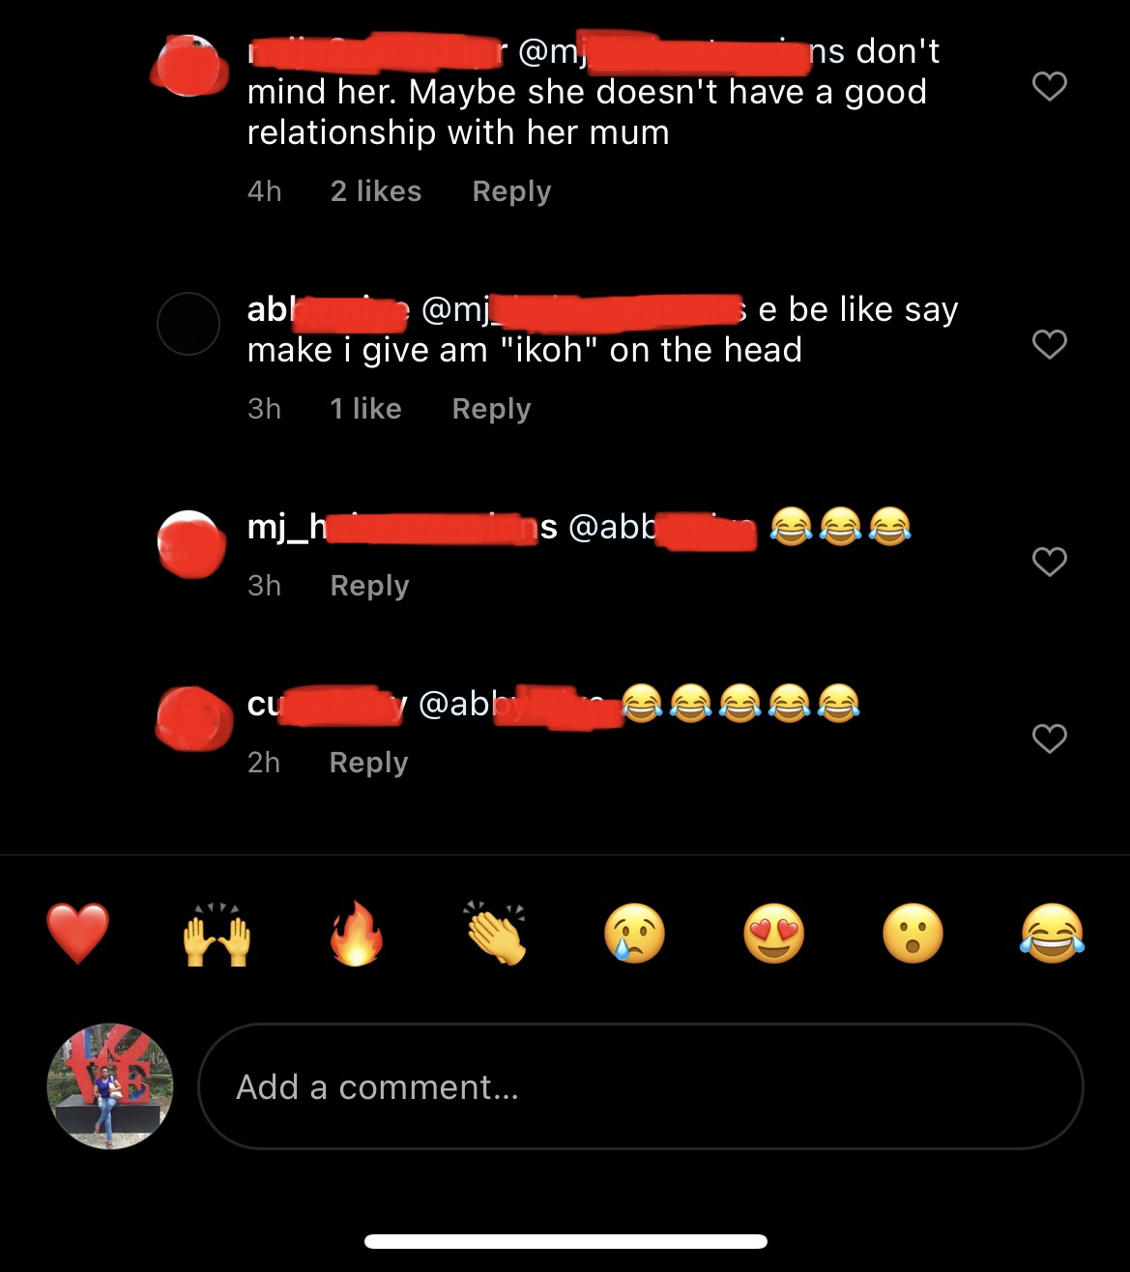
Figure 3 Cheering of profane code-switches in indigenous languages
In addition to knowing that insults and bullying are on IG, excerpt 3 is used to show that those who disagree with people who insult or bully others on the app also use CS to drive home their point by doing the same thing that in initial perpetrators of such behaviour do. CS is used as a conversational skill. They tend to adjust their conversation styles around the sanctions. Consider the discourse in excerpt 3:
Excerpt 3
A: What do you mean by personality issues? Ode
B: @A It means the lady is the one with problem not all women.
C: @A The need to always insult pple is what I don’t understand. What did she say wrong that u called her ode?
D: @A With this comment Na you be the real ode my dear
In Excerpt 3, commenter A while reacting to the issue of a lady being defended for a seemingly bad behaviour on a post, switches to Yorùbá to drive home the absurdity of such an excuse by resorting to insult, ode ‘fool’. Commenter C and D called out A on the unnecessary insult, however, D went further by also insulting A. This example shows two crucial things: (a) that although insults are frequent on IG in the indigenous languages, and many people do not condemn them, they are still insults and evident bullying; (b) insults are mostly preferred in any other language apart from English. Comment D switched to Naija from English when they were ready to insult commenter A. The appendix contains the list of the most frequently used profane words in indigenous Nigerian languages on IG.
7 Conclusion
The discussion above shows that Nigerian indigenous languages are used on social media platforms as well as how they are used. It further facilitates an understanding involving these indigenous languages and the way they are code-switched with English in the context of computer-mediated discourse. Instagram, a popular social media platform, has been used as the reference point. The paper argues that Nigeria’s indigenous languages provide favorable response to profane and taboo expressions.
Code-switching has been found to serve as means of evading censorship penalties. If left unattended, it could portray vulgarity in indigenous Nigerian languages as a norm. Data analyses show how Instagram users avoid cussing and being vulgar in English but do the same when commenting with the indigenous languages. This is noticeable to the extent that when an offensive language is going to be used, they often switch to an indigenous language(s). This study on code-switching strengthens the claim that language use is highly variable in computer-mediated environments. This variationist method of CMD and anonymity tended to encourage bullying among Nigerian IG users.
Finally, the outcome of this research could aid App developers in identifying and making informed decisions on posts and comments written in Nigerian languages as they do for other languages. Future researches on the use of indigenous languages on the Internet could focus on how artificial intelligence would be beneficial for this purpose.
References
Adebola, O. A. (2011). Code-switching and its literacy effects on the acquisition of English
language by Yorùbá/English language bilinguals. Journal of Education and Practice, 2(5), 65-73. www.iiste.org
Agwuocha, U. A. (2019). Language use in the social media and national integration: Current trends and challenges. International Journal of Development and Management Review, 14(1), 264-285.
Akinrẹmi, I. I. (2016). Structural patterns and strategies of codeswitching in Igbo-English
bilingual discourse. Studies in African Linguistics, 45(1&2), 1-25.
http://sal.research.pdx.edu/PDF/450Akinremi.pdf
Al-Qaysi, N. & Al-Emran, M. (2017). Code-switching usage in social media: A case study
from Oman. International Journal of Information Technology and Language Studies, 1(1), 22-38. http://journals.sfu.ca/ijitls
Anyanwu, E. (2023). The indispensable role of English language in combating cyberbullying
among Nigerian youths. Nigerian Journal of African Studies. 5(1), 62-73.
Anyanwu, E. & Udoh, C. V. (2021). Impoliteness in language use: An investigation into
cyber-bullying in Nigeria. Inosr Arts and Humanities I(1), 1-6.
www.inosr.net/inosr-arts-and-humanities/
Auer, P. (1984). On the meaning of conversational code-switching. Interpretive Sociolinguistics 87-112.
Auer, P. (1998.) Code-switching in conversation: Language, interaction and identity.
Routledge.
Awobuluyi, O. (2013). Official language policies in Africa. In O. O. Orie & K. W. Sanders
(Eds.), Selected Proceedings of the 43rd Annual Conference on African Linguistics (pp. 68-76). Cascadilla Proceedings Project. www.lingref.com
Ayeomoni, M. (2006). Code-switching and code-mixing: Style of language use in childhood in Yoruba speech community. Nordic Journal of African Studies. 15(1), 90-99. http://www.njas.helsinki.fi/pdf-files/vol15num1/ayeomoni.pdf
Balogun, N. A., Awodele, T. A., Bello, O. W., Oyekunle, R. A., & Balogun, U. O. (2017).
Impact of social network on the increase of cyberbullying among Nigerian university students in Ilorin Metropolis. Journal of Sustainable Technology, 8(2), 102-111.
Bermudez, C. M., Prasad, P. W. C., Alsadoon, A., & Hourany, L. (2016). Students perception
on the use of social media to learn English within secondary education in developing countries. 2016 IEEE Global Engineering Education Conference (EDUCON), (pp. 968-973). IEEE
Gafaranga, F. (2009). The conversation analytic model of code-switching. The Cambridge
Handbook of Linguistic Code-switching. Cambridge University Press.
Gardner-Chloros, P. (2009). Sociolinguistic factors in code-switching. In B. E. Bullock & A.
J. Toribio (Eds.), Cambridge Handbooks in Language and Linguistics, (pp. 97-113). Cambridge University Press.
Gardner-Chloros, P. (2014). Language diversity and contact. In L. Wei (Ed.), Applied
Linguistics (pp. 151-171). Wiley Blackwell.
Goglia, F. (2004). The interlanguage of Igbo-Nigerians immigrated in Italy, with particular
attention to the interference with English language. In S. Baur (Ed.), II Soggetto Plurilingue (pp. 23-120). Franco Angeli.
Gonulal, T. (2019). The use of Instagram as a mobile-assisted language learning tool.
Contemporary Educational Technology, 10(3), 309-323. https://doi.org/10.30935/cet.590108

Gumperz, J. J. (1973). The communicative competence of bilinguals: Some hypotheses
and suggestions for research. Language in Society, 2(1), 143–154.
Gumperz, J. (1982). Discourse Strategies. Cambridge University Press.
Heller, M. (1988). Codeswitching: Anthropological and Sociolinguistic Perspectives. Mouton
de Gruyter.
Herring, S. C. (1998). Ideologies of language on the Internet: The case of ‘free speech’. Paper presented at the 6th International Pragmatics Conference, Reims, France, July 21.
Herring, S. C. (2001). Computer-mediated discourse. In D. Tannen, D. Schiffrin, & H. Hamilton (Eds.), Handbook of discourse analysis. Blackwell.
Herring, S. C. (2004). Computer-mediated discourse analysis: An approach to researching online behavior. In Barab, S. A., Kling, R., & Gray, J. H. (Eds.), Designing for Virtual Communities in the Service of Learning, (pp. 338-376). Cambridge University Press https://doi.org/10.1017/CBO9780511805080.016
Herring, S. C. (2007). A faceted classification scheme for computer-mediated discourse. Language@Internet 4(1). http:www.languageatinternet.org/articles/2007/761/
Isaiah, A. A. (2022). Tongue mingles: Code-switching in Yorulish child language. Yorùbá:
Journal of Yorùbá Studies Association of Nigeria. 11(1), 62-83. University of Ibadan, Ibadan. http://www.ysan.org
Jegede, O. O. (2012). Roles of codeswitching in multilingual public primary schools in Ile-
Ife, Nigeria. American Journal of Linguistics, 1(3), 40-46.
Johansson, S. (2013). Code-switching in the English classroom: What teachers do and what
their students wish they did. Karistads University: Department of Language, Literature and Intercultural Studies.
Josiah, U. E. & Udofia, I. E. (2020). Social media English in nonnative environment: A study of Whatsapp disscourse in Nigeria. ASUU Journal of Humanities: A Journal of Research and Development, 5(1), 185-211.

King, S. (1996). Researching Internet communities: Proposed ethical guidelines for the reporting of results. The Information Society, 12, 119-127.

Lamidi, M. T. (2017). The syntax of multi-word expression in Yorulish code-mixing. Ghana
Journal of Linguistics 6(2), 30-55.
McClure, E. (1997). The relationship between form and function in written national language-
English code-switching: Evidence from Mexico, Spain and Bulgaria. Trends in Linguistics Studies and Monographs, 106, 125-152.
Murray, D. E. (1988). The context of oral and written English: A framework for mode and medium switching. Language in Society, 17, 351-373.
Mukenge, C. (2012). A discourse analysis of the use of code switching in the film Yellow Card. International Journal of Linguistics, 4, 14-20.
Myers-Scotton, C. (2001). The matrix language frame model: developments and responses.
Codeswitching Worldwide 2, 23-58.
Myers-Scotton, C. (2002). Contact linguistics: bilingual encounters and grammatical
outcomes. Oxford University Press.
Nwosu, K. C., Ementa, C. N., & Ejikeme, P. E. (2018). Cyberbullying among undergraduate
students in a Nigerian university: Awareness and incidence. Romanian Journal of Psychological Studies (pp. 43-58). https://ssrn.com/abstract=3202407
Ofulue, C. I. (2010). Towards the standardisation of Naija: Vocabulary development and
lexical expansion processes. In Proceedings of the Conference on Nigerian Pidgin 2009. Retrieved from http://www.ifra-nigeria.com.
Ofulue, C. I. & Esizimetor, D. O. (n.d.). Guide to standard Naijá orthography: An NLA
Harmonized Writing System for Common Naijá Publications.
https://www.ifra-nigeria.org/ongoing-research-programs/naijasyncor/naija-languej-akedemi
Ogunwale, B., Ojo, T., & Akinsola, A. (2019). Cyberbullying among Nigerian youths:
causes, effects and management. Journal of Educational Research and Practice, 10(1), 1-12.
Owolabi, R. (2020). Cyberbullying, demography, and coping strategies among Nigerian
students. Covenant Journal of Communication 7(1), 84-107. http://journals.convenantuniversity.edu.ng/index.php/cjoc
Poplack, S. (1988). Contrasting patterns of code-switching in two communities. In M. Heller
(Ed.), Codeswitching: Anthropological and Sociolinguistic Perspectives (pp 215–245). Mouton de Gruyter.
Samhan, A. H. (2017). Social aspects in social media: code switching and code mixing in
Twitter. Research on Humanities and Social Sciences 7(18), 110-115. www.iiste.org

Sankoff, D., Poplack, S., & Vanniarajan, S. (1990). The case of the nonce loan in Tamil.
Language Variation and Change. 2, 71-100.
Septiani, M., Petrus, I., & Yunus, M. (2016). The use of code-switching in social media (Line)
by alumni of Sman Sumatera Selatan. chrome://external-file/1490-2869-1-PB.pdf
Sharehu, A. L. (2022). The effects of language use on the social media on Nigeria’s national
integration. Zamfara Journal of Politics and Development.1-7 https://zjpd.com.ng
Sproull, L. & Kiesler, S. (1991). Connections: New ways of working in the networked
organization. MIT Press.

Taiwo, B. E. & Taiwo, R. (2009). Code-switching in contemporary Nigerian hip-hop music. https://www.researchgate.net/publication/255582876_Code-switching_in_contemporary_Nigerian_hip-hop_music/citation/download
Ting, Su-Hie & Yeo, Kai-Liang (2020). Code-switching functions in Facebook wallposts.
Human Behavior, Development and Society. 20(3), 7-18

Appendix
Frequent profane words/phrases in indigenous languages
Yorùbá | Igbo | Naija
werey | ndala | mumu
ashewo/ashawo | zukwanike | yansh
wahala | iberibe | sapa
olodo | ala/ara | japa
ode | ozuor | olosho, ashawo
agbako | mkpi | soapy
osinwin |  | mofos
ori yin daru/buru |  | mugun

